Summary of Thermo-Physical Properties of Sn,
And Compounds of Sn-H, Sn-O, Sn-C, Sn-Li, and Sn-Si

And

Comparison of Properties of Sn, Sn-Li, Li, and Pb-Li

S. Sharafat and N. Ghoniem

Mech. & Aerospace Engr. Dept.
University of California Los Angeles
Los Angeles, CA 90095-1597

APEX Study E-Meeting
University of California Los Angeles
August 24, 2000

UCLA-UCMEP-00-31 Report

ABSTRACT

The APEX evaluation study has identified tin-lithium (Sn-Li) as a new liquid wall coolant for handling high wall loadings. The low vapor pressure of Sn-Li, which is about three orders of magnitude lower than that of lithium, minimizes the effects of material evaporation on the plasma performance for liquid wall designs. Furthermore, because the vapor pressure is dominated by lithium, the allowable operating temperature of the Sn-Li coolant is about 200°C higher than for lithium. The higher allowable operating temperature can result in an increase of coolant exit temperature and therefore, thermal efficiency. However, the compatibility of Sn-Li with structural materials needs to be assessed. Based on some limited experimental data, and our own thermodynamic model, Sn-Li will probably not be compatible with Ni-based and Fe-based alloys. However, V and Nb may be compatible up to about 900°C. Results of our thermodynamic analysis show that many non-metal structural materials, such as nitrides, carbides (including SiC) and some of the oxides are stable in Sn-Li at 773°K.

The APEX study has suggested a Sn-Li mixture of 75 at.% Sn and 25 at.% Li. A summary of thermo-physical data of pure Sn is presented here (10 Tables, and 8 Figures). Because of a lack of thermo physical data of Sn-Li coolants, some properties have, been estimated from pure Sn and Li using a simple rule of mixtures. In addition, some data of Sn-H, Sn-O, Sn-Li, and Sn-C systems are reported. In Section 3 the thermal conductivity, vapor pressure, electrical resistivity, surface tension, dynamic viscosity, and the density of three liquid coolants Sn, Li, and Pb-17 are compared.

We have developed a thermodynamic model to study the stability of non-metals in a Sn-25Li coolant. The model was applied to various oxides, nitrides, and carbides and the results are summarized here. It was found that almost all of the nitrides and carbides and most of the oxides are stable below 900°C and a lithium concentration of 25 at. %.

For purpose of completion, a literature survey was made to report on the number of publications in the area of fusion relevant corrosion and erosion research. Over the past 5 years, more than 75 papers have been published on these subjects. The list of publications is given in Section 5 and is organized in an alphabetical order by the author’s name.

Table of Contents

Table of Contents 3
Table of Tables 5
Table of Figures 5
1. Thermo-Physical Properties of Sn 7
1. 1 Physical Properties of Metallic Tin 7
1. 2 Specific Volume of Sn 10
1. 3 Density of Sn 11
1. 4 Volumetric expansion coefficient (γ) of liquid Sn: 12
1. 5 Compressibility of Sn 12
1. 6 Viscosity of liquid Sn 13
1. 7 Thermal Conductivity of Liquid Sn: 14
1. 8 Surface Tension of Sn: 15
1. 9 Vapor Pressure of Sn 16
1. 10 Boiling Point of Sn 17
1. 11 Heat of Sublimation (L_{s}) and Vaporization (L_{v}): 18
1. 12 Critical Pressure (p_{c}), Temperature (T_{c}), and Volume (V_{c}) 18
1. 13 Heat Capacity of Sn 18
1. 14 Electrical Resistivity (ρ) of liquid Sn 19

2. Thermodynamic Properties of Sn 20
2. 1 Enthalpy, Specific Heat, and Entropy of Sn-Vapor 20
2. 2 Heat of Dissociation, Reaction Enthalpy, and Ionization Potentials of Various Tin-Compounds 21
2. 3 Thermodynamic data of Sn-Silicates 24
2. 3. 1 Specific heat (c_{p}) of Sn-Silicates as a function of temperature 24
2. 4 The Sn-H System 24
2. 4. 1 Absorption of Hydrogen 25
2. 4. 2 H₂-Adsorption 25
2. 4. 3 H₂-Diffusion Coefficient 26
2. 4. 4 Reduction of Sn by atomic hydrogen 26
2. 4. 5 The SnH and SnD Molecule 26
2. 4. 6 Solubility of the gas composition H₂-CO-CO₂ 26
2. 5 The Sn-Li System 27
Stability of Li₂SnO₃* 27
2. 6 The Sn-C System 27
2. 6. 1 Solubility 27
2. 6. 2 The Sn-C Molecule 28
2. 6. 3 The SnCO₃ Molecule 28
2. 7 The Sn-Si System 29
2. 7. 1 Diffusion of Sn in Solid Si and Si in Liquid Sn 29
2. 7. 2 The Sn-Si Molecule 30
2. 8 Sn and Oxygen 30
2. 8. 1 Low Pressure Oxidation 30
2. 8. 2 Oxidation Mechanism: 30
2. 8. 3 Solubility of Oxygen in Liquid Sn 31
2. 9 The SnO-SiO₂ System 32
2. 10 General Literature on Corrosion of Sn with Metals: 32

3. Comparison of Thermo-Physical Properties between Sn, Li, and Pb-Li 33
3. 1 Thermal Conductivity 33
3. 2 Electrical Resistivity 34
3. 3 Surface Tension 35
3. 4 Dynamic Viscosity 36
3. 5 Vapor Pressure 37
3. 6 Density 38

4. Chemical Compatibility of Ceramic Materials with Sn-Li 39

5. Publications on Liquid Metal - Structural and Insulating Materials Interaction (1994 - 1999) 41
5. 1 Publications Relating to Corrosion: 41
5. 2 Publications Relating to Erosion: 47
5. 3 Selected Titles on Corrosion and Erosion: 48

Table of Tables

Table 1: Stable and Unstable Isotopes of Tin [1] 7
Table 2: Physical Properties of Tin [1] 8
Table 3: Thermal Data of Tin [1] 9
Table 4: Thermodynamic Values of Sn-Vapor 20
Table 5: Heat of Dissociation of Sn-Compounds 21
Table 6: Reaction Enthalpies of Sn-Compounds 22
Table 7: Ionization Potentials of Sn-Compounds 23
Table 8: Thermodynamic Data for Sn-Silicates 24
Table 9: Hydrogen Solubility. 24
Table 10: Formation Temperature and Stability of Li₂SnO₃* 27

Table of Figures

Figure 1: Specific volume of liquid Sn as a function of temperature (after Doge [2]). 10
Figure 2: Density of liquid Sn as a function of temperature. 11
Figure 3: Dynamic Viscosity of liquid Sn as a function of temperature. 13
Figure 4: Thermal conductivity of liquid Sn as a function of temperature 14
Figure 5: Surface tension of liquid Sn. 15
Figure 6: Vapor pressure of Sn as a function of temperature. 17
Figure 7: Electrical resistivity of liquid Sn as a function of temperature. 19
Figure 8: Comparison of thermal conductivity of liquid Sn, Li, Pb-17Li, and Sn-25Li. 33
Figure 9: Electrical resistivity of liquid Sn, Pb-17Li, and Li. 34
Figure 10: Comparison of surface tension of liquid coolants 35
Figure 11: Comparison of the dynamic viscosity of liquid coolants. 36
Figure 12: Comparison of the vapor pressure of liquid coolants. 37
Figure 13: Comparison of the density of liquid coolants. 38
Figure 14: Calculated stability of various nitrides, carbides and oxides in liquid Sn-25Li at 773°K. 40

Tin (Sn)

Tin is a silvery-white malleable metal, somewhat ductile, and has a highly crystalline structure. The element has two allotropic forms: gray, or α-tin, with a cubic structure, which changes at 13.2°C into white, or β-tin, the ordinary form of the metal. White tin has a tetragonal structure. When tin is cooled below 13.2°C, it changes slowly from white to gray. This change is affected by impurities such as aluminum and zinc, and can be prevented by small additions of antimony or bismuth. The conversion was first noted as growths on organ pipes in European cathedrals, where it was thought to be the devils work. This conversion was also speculated to be caused by microorganisms and was called "tin plague" or "tin disease" [1].

Tin resists distilled, sea, and soft tap water, but is attacked by strong acids, alkalis, and acid salts. Oxygen in solution accelerates the attack. When heated in air, tin forms SnO₂. It is, or was, used to plate steel, making "tin cans". Tin is used as a component in bell metals [1].

Uses for Sn [1]:

- Used to coat other metals to prevent corrosion or other chemical action (tin cans are made from tin coated steel)
- Alloying agent, important alloys include soft solder, fusible metal, pewter, bronze, bell metal, Babbitt metal, White metal, die casting alloy, and phosphor bronze.
- The chloride (SnCl₂.H₂O) is used as a reducing agent and as a mordant in calico printing.
- Tin salts sprayed onto glass are used to produce electrically conductive coatings. These have been used for panel lighting and for frost-free wind-shields.
- Window glass is made by floating molten glass on molten tin (float glass) to produce a flat surface (Pilkington process).
- A crystalline tin-niobium alloy is super-conductive at very low temperatures.
- Trialkyl and triaryl tin compounds are biocides - there is concern over their environmental effects. Tributyltin is the active ingredient in a type of antifouling paint used on ships.
Reference:
- Mark Winter, “The University of Sheffield and Web Elements Ltd, UK” Document July 2000 (http://www.webelements.com/)

Thermo-Physical Properties of Sn

Physical Properties of Metallic Tin
Tin has the largest number (10) of stable isotopes of any element, but also many unstable isotopes with half-lives ranging from 2.2 minutes to ~10⁵ years:

Table 1: Stable and Unstable Isotopes of Tin [1]

Stable Isotopes
 | Abundance(%)
¹¹²Sn | 0.95
¹¹⁴Sn | 0.65
¹¹⁵Sn | 0.34
¹¹⁶Sn | 14.24
¹¹⁷Sn | 7.57
¹¹⁸Sn | 24.01
¹¹⁹Sn | 8.58
¹²⁰Sn | 32.97
¹²²Sn | 4.71
¹²⁴Sn | 5.89

Unstable Isotopes
 | Half-life |  | Mode of decay¹ | Decay energy (MeV)
¹⁰⁸Sn | 9 m |  | EC
¹⁰⁹Sn | 18.1 m |  | β⁺, EC
¹¹⁰Sn | 4.0 h |  | EC
¹¹¹Sn | 35 m |  | β⁺, EC | 2.52
^{113m}Sn | 20 m |  | IT, EC | 0.079, 1.1
¹¹³Sn | 11.5 d |  | EC | 1.02
^{117m}Sn | 14 d |  | IT | 0.317
^{119m}Sn | 250 d |  | IT | 0.089
^{121m}Sn | 76 y |  | β⁻ | 0.45
¹²¹Sn | 27 h |  | β⁻ | 0.383
¹²³Sn | 125 d |  | β⁻ | 1.42
¹²³Sn | 42 m |  | β⁻ | 1.46
^{125m}Sn | 9.7 m |  | β⁻ | 2.39
¹²⁵Sn | 9.4 d |  | β⁻ | 2.34
¹²⁶Sn | ~10⁵ y |  | β⁻ | ~0.3
¹²⁷Sn | 201 h |  | β⁻
¹²⁷Sn | 4 m |  | β⁻ | ~3.1
¹²⁸Sn | 59 m |  | β⁻ | 1.3
¹³⁰Sn | 2.6 m
¹³¹Sn | 3.4 m
¹³²Sn | 2.2 m
¹EC: Electron Capture; IT: Isomeric Transition

Table 2: Physical Properties of Tin [1]

Density
α-Tin | measured at 288K |  |  | 7.29 g cm⁻³
β-Tin | measured at 288K |  |  | 5.77 g cm⁻³
Liquid | measured at m.p. |  |  | 6.968±0.005 g cm⁻³
 | measured at 600 K |  |  | 6.70 g cm⁻³
 | measured at 1200K |  |  | 6.29 g cm⁻³
Hardness | (Moh scale) |  |  | 1.5 –1.8
 | at 293 K |  |  | 3.9 HB
 | at 373 K |  |  | 2.3 HB
 | at 473 K |  |  | 0.9 HB

Resistivity
α-Tin | measured at 293K |  |  | 12.6 μΩ cm
β-Tin | measured at 273K |  |  | 300 μΩ cm
Young’s modulus (at 293 K) |  |  |  | 49.9 kN mm⁻²
Bulk modulus (at 293 K) |  |  |  | 58.2 kN mm⁻²
Shear strength (at RM) |  |  |  | 12.3 N mm⁻²

Table 3: Thermal Data of Tin [1]
Fusion point | 231.9681 °C
Enthalpy of fusion | 7.06 kJ g atom⁻¹
Boiling point | 2270°C
Enthalpy of vaporization | 296.4 kJ g atom⁻¹
Vapor pressure
at 1096 K | 10⁻⁵ mm Hg
at 1196 K | 10⁻⁴ mm Hg
at 1315 K | 10⁻³ mm Hg
at 1462 K | 10⁻² mm Hg
at 1646 K | 10⁻¹ mm Hg
at 1882 K | 1 mm Hg
Specific heat (C_{v}) at 298 K
α-Tin | 215.5 J kg⁻¹ K⁻¹
β-Tin | 223.3 J kg⁻¹ K⁻¹
Thermal conductivity at 273.2 K
Polycrystalline | 0.682 W cm⁻¹ K⁻¹
Coefficient of expansion at 273 K
Linear | 19.9  10⁶
Cubical | 59.8  10⁶
Expansion on melting | 2.3 %
Surface tension at melting point | 544 mN m⁻¹
Viscosity at melting point | 1.85 mNs m⁻²
Gas solubility in liquid tin
oxygen at 809 K | 0.00018%
oxygen at 1023 K | 0.0049%
hydrogen at 1273 K | 0.04%
hydrogen at 1573 K | 0.36%

Reference:
- P. G. Harrison, “Chemistry of Tin,” Blackie, Glasgow and London, Chapman and Hall New York, 1989.

Specific Volume of Sn
The specific volume of tin, v (in cm³/g), changes from 0.1444 at 300°C to 0.16554 at 1600°C [1]. Doge [2] tabulated the specific volume as a function of temperature between 200 and 1200°C (Fig. 1).

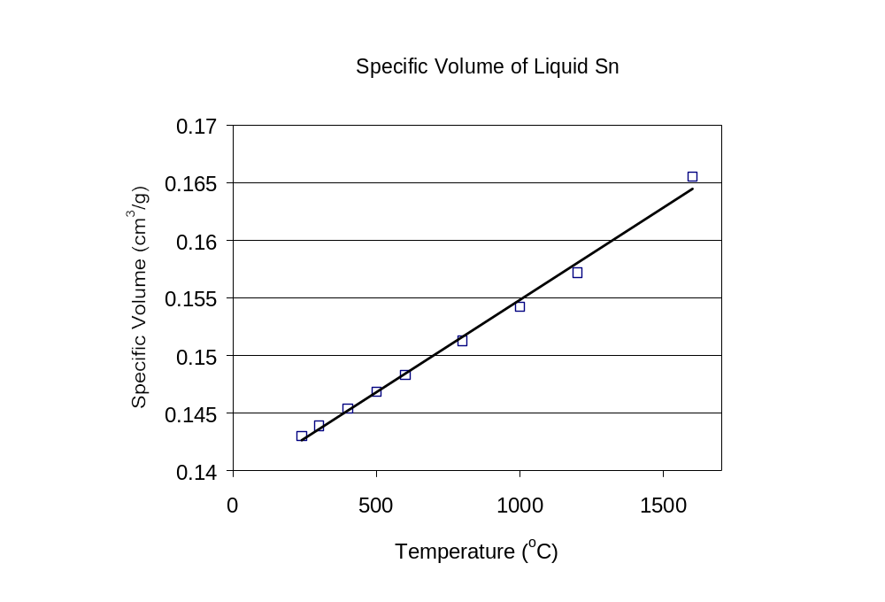
Figure 1: Specific volume of liquid Sn as a function of temperature (after Doge [2]).

References:
- Y. Matuyama, Sci. Rept. Tohoku Univ. 18 (1929) 19/46, 28.
- G. Doge, Z. Naturforsch. 21a (1966) pp. 266-269.

Density of Sn
The density of Sn has been reported by several authors and is shown in Figure 2. The most recent temperature dependence of the density of liquid tin was measured by Alchagirov et al. [1] between 610 and 700°K and are given by:

(1)

The temperature coefficient of the density (ΔD/ΔT) for liquid Sn has been estimated using γ-ray absorption [2,3]:

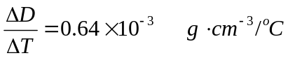 (2)

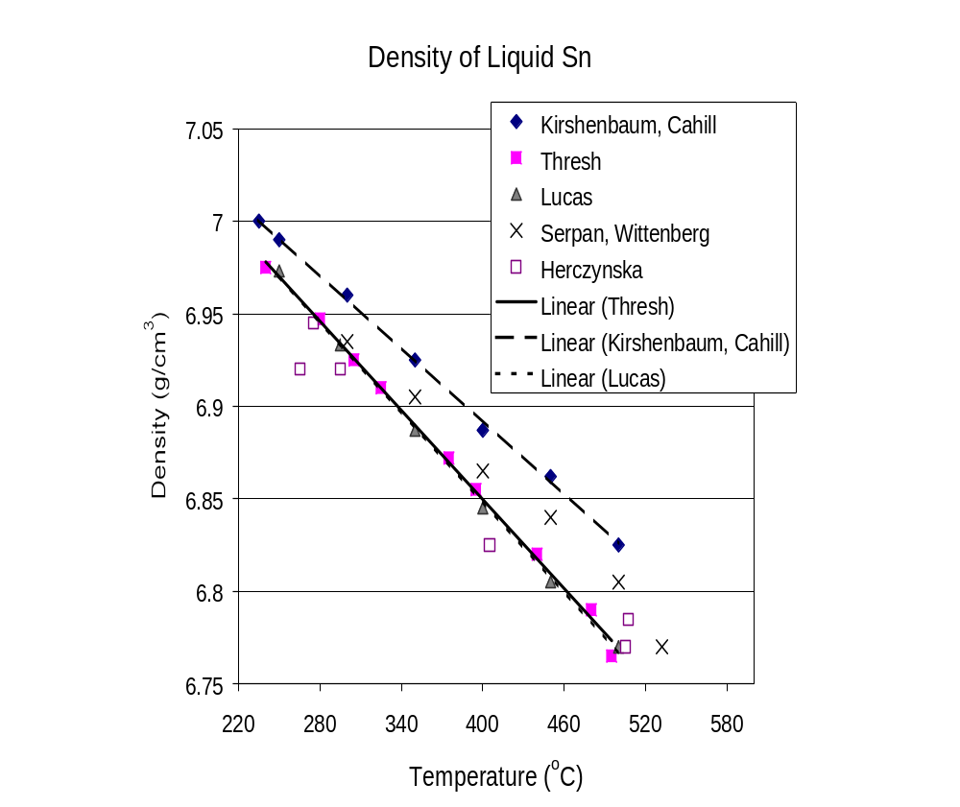
Figure 2: Density of liquid Sn as a function of temperature.

References:
- B. B. Alchagirov, A. M. Chochaeva, “Temperature dependence of the density of liquid tin,” High Temperature 38: (1) 44-48, JAN-FEB 2000
- L. G. Berezkina, A. M. Yakobson, and Zavodsk L. 26 (1960) 171/2;
Ind. Lab. [USSR] 26 (1960) 180/1.
- V.A. Grosse, J. Inorg. Nucl. Chem., 22 (1961) pp. 23-31)
- D. Kirshenbaum, J. A. Cahill, Am. Soc. Metals Trans. Quart. 55 (1962) 844/8.
- H. R. Thresh, A. F. Crawley, D. W. G. White, Trans. AIME 242 (1968) 819/22.
- L. D. Lucas, Mem. Sci. Rev. Met. 61 (1964)1/24, 11.
- C. Z. Serpan, L. J. Wittenberg, Trans. AIME 221 (1961) 1017/20.
- E. Herczynska, Naturwissenschaften 47 (1960) 200/1.

Volumetric expansion coefficient (γ) of liquid Sn:
Doge measured the volumetric expansion coefficient between 240 and 1200°C [1]:
γ = 105 x 10⁻⁶/ºC at 240ºC (3)

γ = 96 x 10⁻⁶/ºC at 1200ºC (4)

Widowski [2] measured the average expansion coefficient between 300 and 1600°C to be:
γ = 113 x 10⁻⁶/ºC 300°C < T < 1600°C (5)

References:
- G. Doge, Z. Naturforsch. 21a (1966) pp. 266-269
- E. Widowski, F. Sauerwald, Z. Anorg. Allgem. Chem., 192 (1930) 145/60, 150.

Compressibility of Sn
The coefficient of compressibility χ is used to determine the modulus of compressibility, K (=1/χ) [1]:

K = 4.6 x 10¹¹ dyn/cm² at 232°C (T_{melt} of Sn)

χ has been reported for 232°C [2], 800°C [3], and 1200°C [2]:

χ = 2.45 x 10⁻¹² cm²/dyn at 232°C

χ = 2.8 x 10⁻¹² cm²/dyn at 800°C

χ = 2.93 x 10⁻¹² cm²/dyn at 1200°C

References:
- K. H. Schramm, Z. Metallk. 53 (1962) pp. 316-320.
- S. I. Filippov, N. B. Kazakov, L. A. Pronin, Izv. Vysshikh Uchebn. Savedenii Chernaya Met. 9 (1066) 8/14.
- C. M. Gittis, I. G. Mikhailov, Akust. Zh., 11 (1965) 434/7; Soviet Phys.-Acous. 11 (1965) 372/5.

Viscosity of liquid Sn
The dynamic viscosity, η (given in cP), has been reported between the melting temperature and 1000°C.

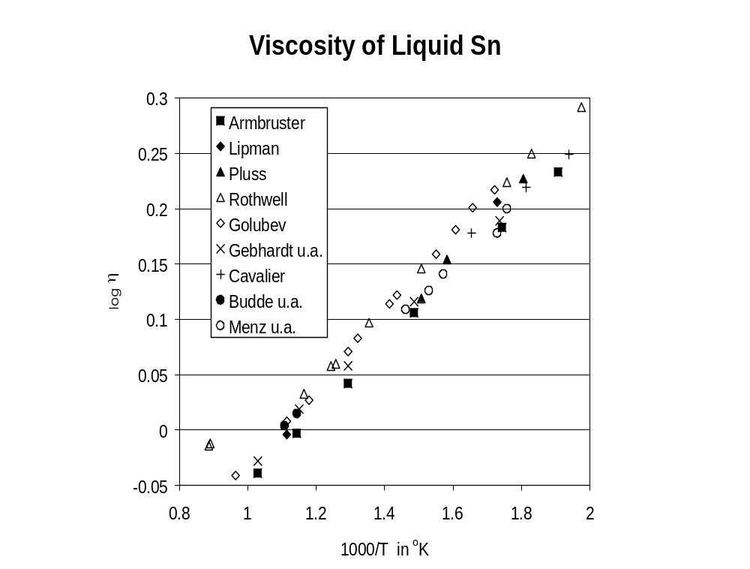
Figure 3: Dynamic Viscosity of liquid Sn as a function of temperature.

References:
- J. C. Armbruster, Diss. Paris (1961) p. 1-78), M. Pluss, Z. Anorg. Allgem. Chem. 93 (1915) 1/44, 19):
- M. S. Lipman, Zavodsk. Lab 16 (1950) 1349/54.
- M. Pluss, Z. Anorg. Allgem. Chem., 93 (1915) 1/44, 19.
- E. Rothwell, J. Inst. Metals 90 (1962) 38/94, 392.
- F. Golubev, V. A. Petrov, Zavodsk. Lab. 7 (1938) 816/8.
- E. Gebhardt, M. Becker, H. Sebastian, Z. Metallk., 46 (1955) 669/72.
- G. Cavalier, Diss. Paris 1962 in: the Physical Chemistry of Metallic Solutions and Intermetallic Compounds, Bd. 2, 4 D, London 1959, p. 2/12, 7.
- J. Budde, K. Fissher, W. Menz, F. Sauerwald, Z. Physik. Chem. (Leibzig) 218 (1961) 100/7, 105.
- W. Menz, F. Sauerwald, K. Fischer, Acta. Met. 14 91966) 1617/23, 1620.

Thermal Conductivity of Liquid Sn:
The thermal conductivity of liquid tin was reported by Dutchak et al. [1]:
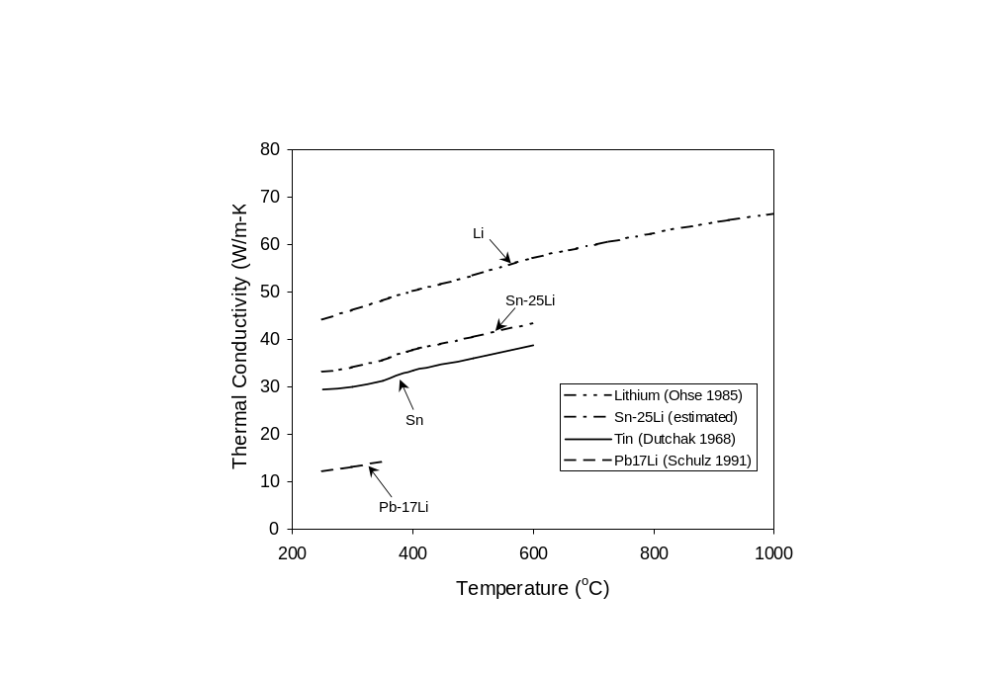
Figure 4: Thermal conductivity of liquid Sn as a function of temperature

Reference:
- Ya. I. Dutchak, V. P. Osipenko, P. V. Panasyuk, Izv, Vyssh. Zavedenii, Fiz, 1968, No. 10, p. 154/C, C.A. 70[1969] No. 61918.
- R. W. Ohse (Ed.) Handbook of Thermodynamic and Transport Properties of Alkali metlas, Inter. Union of Pure and Applied Chemistry Chemical Data Series No. 30. Oxford: Blackwell Scientific Publ., 1985, pp. 987.
- B. Schulz, Fusion Eng. Design 14 (1991) 199.

Surface Tension of Sn:
A large scatter in the value of the surface tension, γ ( in dyn/cm), exists. The scatter is potentially due to measurement techniques and to the impurity levels of the liquid Sn. Results are summarized in Fig. 5:

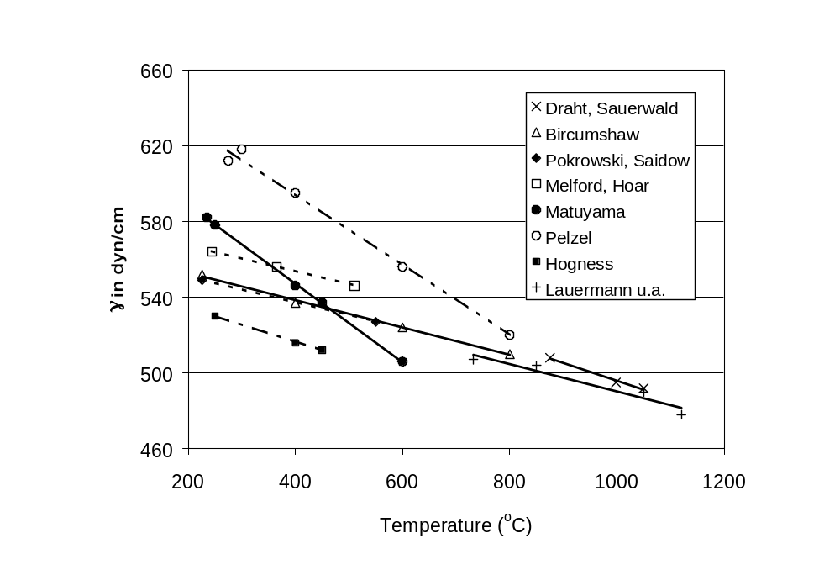

Figure 5: Surface tension of liquid Sn.

References:
- G. Draht, F. Sauerwald, Z. Anorg. Allgem. Chem. 162 (1927) 301/20, 304.
- L.L. Bircumshaw, Phyl. Mag. 17 No. 7 (1934) 181/91, 186.
- N. L. Pokrovskii, m. Saidov, Fiz. Metal. i Metalloved. 2 (1956) 546/51, 550.
- D. A. Melford, T. P. Hoar, J. Inst. Metals 85 (1956/57) 197/205, 201.
- Y. Matuyama, Sci. Rept. Tohoku Univ. I 16 (1927) 555/62, 559.
- E. Pelzel, Berg-Huttenmann. Monatsh. Monta., Hochshule Leoben 93 (1948) 248/54, 252.
- T. R. Hogness, J. Am. Chem. Soc. 43 (1921) 1621/8, 1625.
- Lauermann, G. Metzger, F. Sauerwald, Z. Physic. Chem.[Leibzig] 216 (1961)
42/9, 43).

Vapor Pressure of Sn
Mass-spectroscopy of Sn-vapor shows the presence of positive ion-clusters:
Sn₂, Sn₃, Sn₄, Sn₅ and Sn₆ [1]. The vapor pressure of Sn between 500°C and 1200°C has been measured [2] and is shown in Fig.6. Measurements between 800°K and 2940°K were reported by Honig [3]. For a limited temperature range between 1424 and 1638°K the following expression can be used for the vapor pressure [4]:

lg p_{k} = 5.471 –15730/T (p in atm, T in °K) (6)

lg p_{T} = 5.810 –16160/T (p in atm, T in °K) (6)

where the p_{k} indicates measurements using the Knudson effusion method, and p_{T} a torsion-based method. Given the spread of experimental data, Nemeyanov derived a general expression for the vapor pressure [5] as:

lg p = – 9.32188 – 14023.92/T – 8.812210⁻⁴T + 5.6201 lg T (7)

where the pressure is in atm and the applicable temperature range is 1424<T<1753 °K.

References:
- (G. Kohl, Z. Naturforsch. 9a (1954) 913/8, 918).
- K. K. Kelly, U.S. Bur. Mines Bull. Nr. 383 (1935) 1/132, 105.
- R. E. Honig, D. A. Kramer, RCA Rev. 30 (1969) 285/305, 297.
- L. Brewer, R. F. Porter, J. Chem. Phys. 21 (1953) 2012/3.
- A. N. Nesmeyanov, Dablenie Para Khimicheskikh Elementov, Moskva 1961, p. 231,369; Vapour Pressure of the Elements, London 1963, P. 273, 445.
- M. Abdou, et al., “On the Exploration of Innovative Concepts for Fusion Chamber Technology: APEX Interim Report,” University of California School of Engineering and Applied Science, UCLA-ENG-99-206, Nov. 1999.
- M. Abdou, et al., “ Blanket Comparison and Selection Study Final Report,” Argonne National Laboratory Report, ANL/FPP-84-1, Vol. 2.,1984
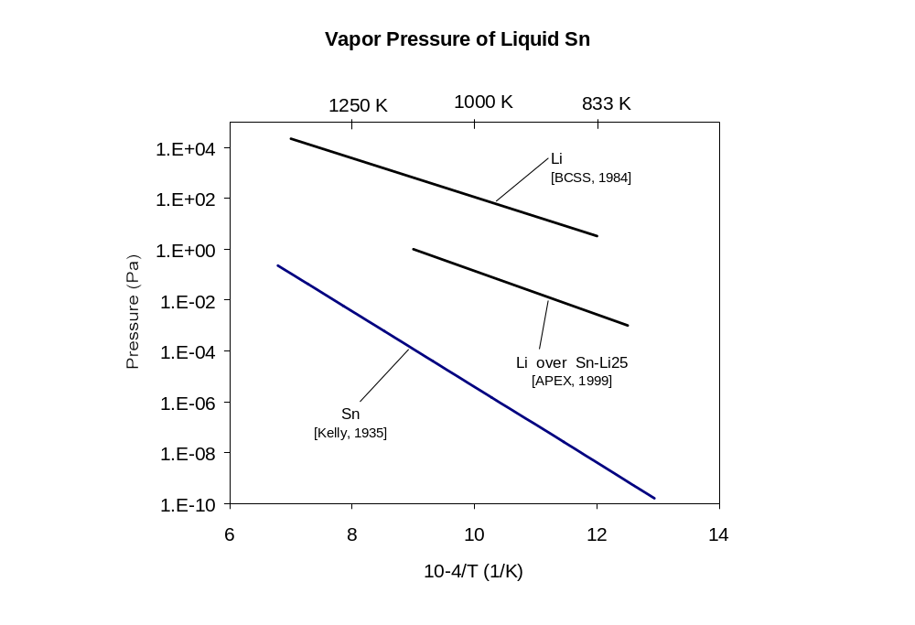
Figure 6: Vapor pressure of Sn as a function of temperature.

Boiling Point of Sn
At 760 Torr the boiling point of Sn has been measured [1] to be:

T_{boil} = 2780 ± 20 °K (8)

A boiling point values of 3000°K has been reported [2]. It is speculated that the spread in boiling point may be caused by the formation of complex gases.

References:
- D. T. Stull, G. C. Sinke, Thermodynamic Properties of the Elements, Washington 1956, p. 33.
- L. L. Quill, The Chemistry and Metallurgy of Miscellaneous Materials, Thermodynamics, New York – Torronto – London 1950, p. 33.

Heat of Sublimation (L_{s}) and Vaporization (L_{v}):
The heat of sublimation at 298°K and 232°C have been reported to be [1]:
L_{s} = 71.9 ± 2.0 kcal/mol at 298°K: (9)
L_{s} = 71.9 ± 1.5 kcal/mol at 232°C (10)

The heat of vaporization [2] is given by:

L_{v} = 70.8± 1.5 kcal/mol at 2623°C (11)

The melting temperature and the boiling temperature were reported to be 232°C and 2623°C, respectively.

References:
- A. W. Searcy, R. D. Freeman, J. Am. Chem.Soc. 76 (1954) 5229/32.
- O. Kubaschewski, W. L. Wvans, C. B. Alcock, Metallurgical Thermochemistry,4. Aufl., Oxford 1967, p. 385.

Critical Pressure (p_{c}), Temperature (T_{c}), and Volume (V_{c})
These were reported by Searcy and Freeman [1] and Gates [2]:

p_{c} = 524 atm
T_{k} = 5809°K
V_{c} = 264.9 cm³/mol

References:
- A. W. Searcy, R. D. Freeman, J. Am. Chem. Soc. 76 (1954) 5229/32.
- D. S. Gates, G. Thodos, A.I.Ch.E. (Am. Inst. Chem. Engrs.) J 6 (1960) 50/4.

Heat Capacity of Sn
The heat capacity at the melting point (232°C) has been reported to be
C_{p} = 7.10 cal/(mol-°K) [1] . Raising the temperature to 800°C reduces the heat capacity from 7.10 to C_{p} = 6.87 cal/(mol-°K). An expression for the heat capacity as a function of temperature was given as [1]:

Cp = 9.97 – 9.15  10⁻³T + 6.5  10⁻⁶T² [cal/(mol-°K)] (11)
References:
- T. W. Chapman, Mater. Sci. Eng. 1 (1966) 65/9

Electrical Resistivity (ρ) of liquid Sn
At the melting temperature the electrical resistivity (ρ) of Sn doubles from the solid value of ρ_{s} = 22.8 μΩ-cm to the liquid value of ρ_{l} = 48.0 μΩ-cm [1]. However, there is a large scatter in the reported data of ρ (see the Fig. 7).

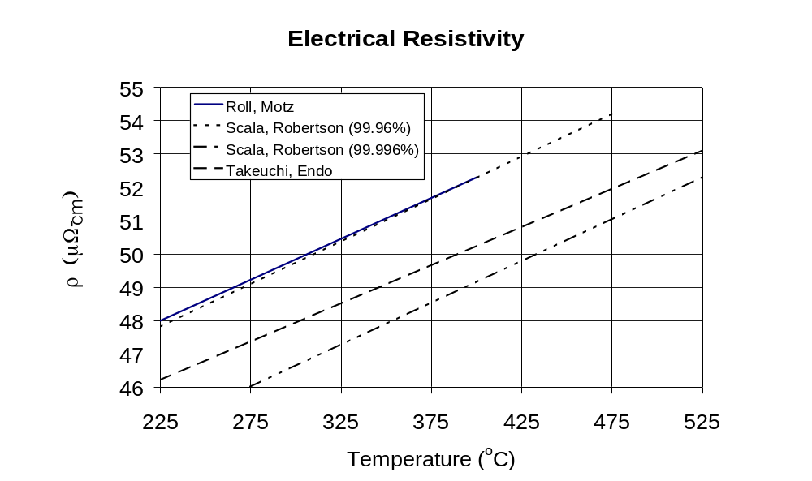
Figure 7: Electrical resistivity of liquid Sn as a function of temperature.

The following temperature dependent correlations have been reported (ρ in μΩ-cm; T in °C):
ρ(T) = 40.88 + 0.0272  T for T < 315°C (12)

ρ(T) = 41.16 + 0.0263  T for T > 315°C (13)

References:
- A. Roll, H. Motz, Z. Metallk. 48 (1957) 272/80, 274.
- E. Scala, W. D. Robertson, J. Metals, 5 (1953) Trans. 197, p. 1141/7, 1144.
- S. Takeuchi, H. Endo, Trans. Japan Inst. Metals 3 (1962) 30/5.
- H. A. Davis, J. S. L. Leach, Phys. Chem. Liquids 2 (1970) 1/12, 5.
- P. D. Adams, Diss. Univ. of London, 1964

Thermodynamic Properties of Sn

Enthalpy, Specific Heat, and Entropy of Sn-Vapor
Thermodynamic values of enthalpy, specific heat, and entropy were determined spectroscopically assuming, that Sn-vapor obeys the ideal gas law [1-3].

Table 4: Thermodynamic Values of Sn-Vapor
Temperature  (°K) | H°– H°_{298.15}  (kcal/mol) | C°_{p}  (kcal/mol-°K) | S°  (kcal/mol-°K)
298 | 0 | 5.08 | 40.24
400 | 535 | 5.47 | 41.79
600 | 1747 | 6.66 | 44.22
800 | 3179 | 7.57 | 46.28
1000 | 4735 | 7.91 | 48.01
1400 | 7866 | 7.62 | 50.65
1800 | 10805 | 7.09 | 52.20
2200 | 13555 | 6.69 | 53.88
2600 | 16178 | 6.44 | 54.98
3000 | 18717 | 6.27 | 55.89
3200 | 19964 | 6.199 | 56.29
3400 | 21198 | 6.139 | 56.66
3600 | 22420 | 6.086 | 57.01
3800 | 23633 | 6.038 | 57.34
4000 | 24836 | 5.995 | 57.65
4400 | 27218 | 5.919 | 58.22
4800 | 29573 | 5.859 | 58.73
5200 | 31907 | 5.815 | 59.20
5600 | 34228 | 5.791 | 59.63
6000 | 36543 | 5.790 | 60.02

References:
- [D. R. Stull, G. C. Sinke, Thermodynamic Properties of the Elements, Washington 1956, p. 209.
- R. Hultgren, R. L. Orr, P. D. Anderson, K. K. Kelly, Selected Values of Thermodynamic Properties of Metals and Alloys, New York – London, 1963, p. 262.
- J. S. Gordon, ADI-6930 (1961) 1/3.

Heat of Dissociation, Reaction Enthalpy, and Ionization Potentials of Various Tin-Compounds
L. V. Gurvich, et al., [1], reported the heat of dissociation, reaction enthalpies, and ionization potentials of various tin compounds. The heat of dissociation 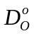(kcal/mole) is defined as:
(14)
where 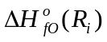is the enthalpy of formation at 0°K and R_{i} is reactant i.

Table 5: Heat of Dissociation of Sn-Compounds
Compound | D_{o} (kcal/mole)
Sn₂ | 46 ± 4
SnAg | 32 ± 5
SnAu | 60 ± 4
SnCu | 42 ± 4
SnBr | 80 ± 1
SnBr⁺ | 80 ± 12
SnCl | 98 ± 4
SnF | 112 ± 3
SnF⁺ | 112 ± 12
SnH | 60 ± 3
SnI | 55 ± 2
SnO | 126 ± 2
SnO⁺ | 53 ± 15
SnS | 110.2 ± 0.8
SnS⁺ | 55 ± 12
SnSe | 95 ± 8
SnSe⁺ | 40 ± 12
SnTe | 75.0 ± 1.0
SnTe⁺ | 36 ± 12

Table 6: Reaction Enthalpies of Sn-Compounds
Reaction | ΔH_{fO} (kcal/mole) | ΔH_{f298} (kcal/mole)
SnO = Sn + O | 126 ± 2 | 127
(SnO)₂ = 2SnO |  | 66 ± 4
(SnO)₃ = (SnO)₂ + SnO |  | 69 ± 6
(SnO)₄ = (SnO)₃ + SnO |  | 71 ± 7
(SnO)₄ = 2(SnO)₂ |  | 74 ± 9
SnF = Sn = F | 112 ± 3 | 112
SnF₂ = SnF + F |  | 105
(SnF₂)₂ = 2SnF₂ |  | 41
(SnF₂)₃ = (SnF₂)₂ + SnF₂ |  | 30
SnCl = Sn + Cl | 98 ± 4 | 98
SnCl₂ = SnCl + Cl |  | 81
SnBr = Sn + Br | 80 ± 1 | 80
SnBr₂ = SnBr + Br |  | 74
SnI = Sn + I | 55 ± 10
SnI₂ = SnI + I |  | 66 ± 10
SnS = Sn + S | 110.2 ± 0.8 | 111.1
Sn₂S₂ = 2SnS |  | 49 ± 5
Sn₂S₂ =Sn₂ + S₂ |  | 126 ± 6
SnSe = Sn + Se | 95 ± 5
Sn₂Se₂ = 2SnSe |  | 46.5 ± 0.4
Sn₂Se₂ = Sn₂ + Se₂ |  | 119 ± 10
SnTe = Sn + Te | 75.0 ± 1.0 | 75.6
SnTe₂ = SnTe + Te |  | 48.9 ± 3.0
SnTe₂ = SnTe + 1/2Te₂ |  | 17.5 ± 0.3
SnTe₂ = Sn + Te₂ |  | 61.7 ± 2.0
Sn₂Te₂ = SnTe₂ + Sn |  | 73.6 ± 8.0
Sn₂Te₂ = 2SnTe |  | 46.9 ± 6.0
Sn₂Te₂ = Sn₂ + Te₂ |  | 90 ± 8
SnWO₄ = SnO + WO₃ | 136 ± 15
Sn₂WO₅ = SnO + SnWO₄ | 66 ± 15

Table 7: Ionization Potentials of Sn-Compounds
Compound | Ionization Potential (eV)
SnO | 10.5 ± 0.5
Sn₂O₂ | 9.8 ± 0.5
Sn₃O₃ | 9.8 ± 0.5
Sn₄O₄ | 9.2 ± 0.5
SnH₄ | 9.2 ± 1.0
Sn₂H₆ | 9.0 ± 0.3
SnF | 7.4 ±0.5
SnF₂ | 11.5 ± 0.5
SnCl | 6.6 ± 0.5
SnCl₂ | 10.2 ± 0.5
SnCl₃ | 9.5 ± 0.5
SnCl₄ | 11.5 ± 0.5  12.10 ± 0.05
SnBr | 7.4 ± 0.5
SnBr₂ | 10.0 ± 0.4
SnBr₃ | 9.1 ± 0.5
SnBr₄ | 10.6 ± 0.4  11.0 ± 0.1
Sn₂F₄ | 10.5 ± 0.5
Sn₃F₆ | 10.5 ± 0.5
SnS | 9.7 ± 0.5
Sn₂S₂ | 9.4 ± 0.5
SnSe | 9.7 ± 0.5
Sn₂Se₂ | 9.8 ± 0.5
SnTe | 9.1 ± 0.5

References:
- L. V. Gurvich, et al., “Heat of Dissociation of Chemical Bonds and Ionization Potentials,” Published by Nauka, Moskow, 1974.

Thermodynamic data of Sn-Silicates
Enthalpy of formation (ΔH), free energy of formation (ΔG) in kcal/mol and entropy of formation (ΔS) in cal/mol-ºK between 298 and 1500ºK have been estimated [1]:

Table 8: Thermodynamic Data for Sn-Silicates
Compounds | -ΔH₂₉₈ | -ΔG₂₉₈ | ΔS₂₉₈
SnSiO₃ | 270 | 252 | 24.19
Sn₂SiO₄ | 301.2 | 283.38 | 34.93

References:
- D. E. Wilcox, Ind. Eng. Chem. 55 No.7 (1963) 32/9, 37.

Specific heat (c_{p}) of Sn-Silicates as a function of temperature
For SnSiO₃ [1]:
c_{p} = 24.06 + 9.32x10⁻³T – 2.35x10⁻⁵T² cal/mol-ºK (15)

and for Sn₂SiO₄:
c_{p} = 33.026 + 14.31x10⁻³T – 2.09x10⁻⁵T² cal/mol-ºK (16)

References:
- V. A. Gorochovskii, E. A. Kregius, V. A. Vlasov, T. B. Dashkevich, Izv. Akad. Nauk SSSR Neorgan. Materialy 7 (1971) 2033/5; Inorg. Materials (USSR) 7 (1971) 1810/2.

The Sn-H System
At room temperature, molten Sn does not absorb any H₂ [1]. At 1000°C 100 g Sn will dissolve 1.77 cm³ of H₂ [2]. Between 1150 and 1300°C no dissolution of H2 in liquid Sn is observed, based on monitoring the H₂ pressure [3]. However, hydrogen pressures above 10 Torr indicate some dissolution of H₂ [4]. Atomic hydrogen reacts with Sn and forms SnH₄[5].

Table 9: Hydrogen Solubility.
Temperature (ºC) | H₂ (cm³) /100 g Sn | References
800 | 0.3 | [6]
1000 | 1.77 | [7]
1000-1300 | 0.02 – 0.43 (at 1 atm) | [8]
References:
- A. Sieverts, Z. Elektochem. 16 (1910) 707/13, 708.
- K. Iwase, Sci. Rept. Tohoku Imp. Univ. I 15 (1926) 531/66, 543.
- R. Schafer. W. Klemm, J. Pract. Chem. [4] 5(1(58) 233/41, 240.
- E. Bauer, R. Brunner, Helv, Chi, Acta 17 (1934) 958/69.
- T. G. Pearson, P. L. Robinson, E. M. Stoddart, Proc. Roy. Soc. [London] A 142 (1933) 275/85, 280.
- L. L. Bircumshaw, Phil. Mag.[71] 1 (1926) 510/22, 513.
- K. Iwase, Sci. Rept. Tohoku Imp. Iniv., 15 (1926) 531/66, 544.
- M .B. Bever, C F. Floe, Trans. AIME, 156 (1944) 149/59.

Absorption of Hydrogen
At room temperature, molten Sn does not absorb any H₂ [1]. At 1000°C 100 g Sn will dissolve 1.77 cm³ of H₂ [2]. Between 1150 and 1300°C no dissolution of H₂ in liquid Sn is observed, based on monitoring the H₂ pressure [3]. However, hydrogen pressures above 10 Torr indicate some dissolution of H₂ [4]. Atomic hydrogen reacts with Sn and forms SnH₄[5].

References:
- A. Sieverts, Z. Elektochem. 16 (1910) 707/13, 708.
- K. Iwase, Sci. Rept. Tohoku Imp. Univ. I 15 (1926) 531/66, 543.
- R. Schafer. W. Klemm, J. Pract. Chem. [4] 5(1(58) 233/41, 240.
- E. Bauer, R. Brunner, Helv, Chi, Acta 17 (1934) 958/69.
- T. G. Pearson, P. L. Robinson, E. M. Stoddart, Proc. Roy. Soc. [London] A 142 (1933) 275/85, 280.

H₂-Adsorption
Measurements of the surface tension of Sn in a low pressure H₂-atmosphere showed that the number of adsorbed H₂-molecules is about 10% the total number of surface Sn-atoms. Results of statistical thermodynamic calculations have estimated the adsorption energy to be about:

E_{adsorp} = 12.67 kcal/mol

which is similar to the adsorption energy of di-atomic gas molecules on solid metal surfaces [1].

References:
- M. Ishigura, Mem. Int. Sci. Ind. Res. Osaka Univ., 8 (1951) 78/82.

H₂-Diffusion Coefficient
The diffusion coefficient of H₂ in liquid Sn is larger than that of H₂ in liquid Ag, Cu, and Ni [1].

References:
- E. M .Sacris, N. A. D. Parlee, Met. Trans., 1 (1970) 3377/82.

Reduction of Sn by atomic hydrogen
Glow discharge experiments in the presence of dilute H₂-gas have shown the production of SnH₄ only in the presence of hydrocarbons (catalytic reactions).

The SnH and SnD Molecule
Based on the size difference of 0.532 Å between the atomic radius and the radius of the outer orbit, Pollitzer [1] concludes that the H-atom has to overcome a larger barrier to attachment to Sn than to metals in the I and III group.

Significant detail is available on the electron configuration, the rotational and vibrational constants and the inter-nuclear distances of the SnH and SnD molecules.

The dissociation energy has been calculated to be:
E_{diss} = 2.7 eV
References:
- P. Pollitzer, J. Phys. Chem., 70 (1966) 4041/4.

Solubility of the gas composition H₂-CO-CO₂
The solubility of the gas composition H₂-47, CO-45, CO₂-0.8 (vol. %) was measured between 1000° and 1300°C.

Temperature (ºC) | H₂-CO-CO₂ (cm³) /100 g Sn | Ref.
1000-1300 | 5 – 12 | [1]
References:
- S. B. Delachanal, Compt. Rend. 148, 1909) 561/4.

The Sn-Li System
Li₂SnO₃ is a stable crystalline solid above 1000ºC.

Table 10: Formation Temperature and Stability of Li₂SnO₃*
Compounds | Formation Temp. (ºC) | Stability of Li₂SnO₃* | References
SnO₂ ; Li₂O | 800 | α-Phase:  stable below 800°C  β-Phase:  stable above 1000°C | [1]
SnO₂ ; Li₂OC₃ | 1000 | α-Phase:  stable below 800°C  β-Phase:  stable above 1000°C | [2]
* Li₂SnO₃ is formed from the solid compounds with an approximate molar fraction of
1;1.05, by heating at the formation temperature for about 10 hr.

Li₂SnO₃ is luminescent when exposed to UV-rays (2537 ), or α-rays (Po-based 5.6 MeV α’s). TiO₂ activated Li₂SnO₃ can be used as a neutron scintillator, because the α-energy from the ⁶Li(n,α)³H reaction is of the same range as the α’s from Po.

Li₂SnO₃ is stable in H₂O or methanol. Equimolar mixtures of LiO₂ and Li₂SnO₃ heated at 360ºC show no sign of dissolution, however, between 450 and 900°C partial formation of Li₈SnO₆ has been reported [1,3]. (Li₈SnO₆ is stable up to 1000°C but melts at 1050°C [5]).

References:
- D. Rade, Diss. Karlsruhe T. H. !958, p. 60
- F. Hund, G. Lang, Naturwissenschaften 38 (1951) 502/3.
- W. Pucall, Silicat-Z., 2 (1914) 65/76.
- D. Rade, Diss. Karlsruhe T. H. !958, p. 64/6.

The Sn-C System

Solubility
Liquid Sn dissolves only trace amounts of C [1]. For all practical applications, Sn and C are immiscible. Estimates of solubility are given as [1]:

lg x_{c} = -13800/T + 0.315 (17)

where x_{c} is the mole fraction of C and T is in ºK.
References:
- O. Ruff, B. Bergdahl, Z. Anorg. Allgem. Chem., 106 (1919) 76/94, 91.

The Sn-C Molecule
The binding energy of the a Sn-C molecule has been estimated to be [1]:

E_{bind} = 60 kcal/mole

The vibration frequency (ω) of this molecule has been reported to be between 944.4 and 1021 cm⁻¹. [2,3].

References:
- M. L. Huggins, J. Am. Chem. Soc., 75 (1953) 4123/4, 4125.
- Y. P. Varshni, Z. Physik. Chem. (Leibzig), 204 (1955) 188/93, 191.
- P. L. Goodfriend, Can. J. Phys. 45 (1967) 3425/7.

The SnCO₃ Molecule
The enthalpy of formation of SnCO₃ has been estimated to be [1]:

ΔH₂₉₈ = -177 kcal/mole

and that of the formation of Sn(HCO₃)₂ has been estimated to be [1]:

ΔH₂₉₈ = -353 kcal/mole

and the partial pressure of CO₂ for a hypothetical carbonate of Sn [Sn(CO₃)₂] has been estimated to be [2]:

lg p_{CO2} = -895.T + 9.803 (p in atm; T in °K) (18)

A related molecule, Sn(HCO₂)₂ has an enthalpy of formation given by:

ΔH = -209 ± 15 kcal/mole

Although this compound (Tin-formiate) is stable in air and in vacuum, it does dissociate when heated between 198 and 200°C, without first melting.

References:
- D. E. Wilcox, Ind. Eng. Chem., 55 No. 7 (1963) 32/9, 3.
- E. Erdos, Collection Czech. Chem. Commun., 27 (1962) 2152/67, 2165.

The Sn-Si System
Investigations of Sn-Si compounds have been reported only sporadically, with most of the attention given to the SnO-SiO₂ system. Thermodynamic measurements indicate the existence of the Sn₂SiO₄ compound, which can be prepared by melting the tow oxides [1,2].

Tin and Si form, what is called a “degenerative” eutectic near the melting temperature of Sn (232ºC). For all practical purposes, Si is considered insoluble in liquid Sn at low temperatures. However, the solubility of Si in Sn at 1100°C is about 10 at.%, but increases as the melting temperature of Si (1417°C) is reached [1].

The solubility of Sn in solid Si (k_{Sn-Si}) at 800°C and up to 1412°C has been measured as [3]:

k_{Sn-Si} = 6.5x10⁻⁴ at 800°C
k_{Sn-Si} = 6.5x10⁻² at 1412°C

The enthalpy of mixing at 50 at. % is given by [4]:

ΔH = 1.300 kcal/g-atom

and for solid Sn in liquid Si, it is [5]:

ΔH = 9.160 kcal/g-atom

References:
- S. Tamaru, Z. Anorg. Allgem. Chem., 61 (1909) 40/5, 41.
- W. Johnson, M. Hansen, AF-TR-6383 (1951) 1/133, 21, 76; N. S. A. 5 (1951) No. 6757.
- F. A. Trumbore, C. R. Isenberg, E. M. Porbansky, Phys. Chem. Solids 9 (1959) 60/9, 63.
- W. Ptak, Arch. Hutnictwa, 1 (1956) 53/97, 91.
- G. M. Kuznetsov, S. K. Kuznetsova, Izv. Akad. Nauk SSSR Neorgan. Materialy 2 (1966) 643/9; Inorg. Materials (USSR) 2 )1966) 555/60, 557.

Diffusion of Sn in Solid Si and Si in Liquid Sn
Between 800°C and 1200°C the diffusion zone of Sn in solid Si rises with increasing temperature. Above 850°C the diffusion rate increases exponentially from 100 nm. The activation energy for Sn diffusion in Si has been estimated to be 7.3 kcal/mole [1,2] and for Si in liquid Sn it is 5 kcal/mole.

References:
- V. N. Lozovskii, A. I. Kalinyuk, V. I. Buddo, Tr. Novocherk. Politekhn. Inst. (1970) No. 208, p. 50/4.
- V. N. Lozovskii, A. I. Kalinyuk, Fiz. Kondens. Sred., (1969/70) 87/90.

The Sn-Si Molecule
The binding energy of the hypothetical Sn-Si molecule has been estimated to be [1]:

E_{bind} = 37.0 kcal/mole at 300°K

The vibration frequency (ω) of this molecule has been estimated to be between 555.6 and 608 cm⁻¹ [2,3].

References:
- P. Manca, Phys. Chem. Solids 20 (1961) 268/73, 269.
- Y. P. Varshni, Z. Physik. Chem. (Leibniz) 204 (1955) 188/93, 191.
- P. L. Goodfriend, Can. J. Phys. 45 (1967) 3425/7.

Sn and Oxygen
In dry air, Sn is stable against oxidation at room temperature [1]. The time to develop a layer of oxide (yellow discoloration) has been estimated to be about 3.8  10⁸ years [2].

A relative humidity of 80% increases the oxidation rate by about 50% compared with that in dry air [3]. In the presence of H₂O, Sn shows distinct discoloration after 100 days, and in flowing air, oxidation becomes visible within 14 days [4]. Oxidation in humid air results in the formation of an oxide layer, which prevents further oxidation at room temperature. A rise in temperature increases the oxidation rate.

The oxide, which forms with pure O₂ between 0°C and 200°C is a α-SnO [5]. Above 280°C both SnO and SnO₂ form, while above 390°C only SnO₂ will form [6]. When Sn powder with an average diameter of 2.5  10⁻⁶ cm is molten at 505°C a 50  thick SnO layer is formed [7].

Low Pressure Oxidation
At low pressures, 2  10⁻⁴ Torr, oxidation results only in the formation of SnO regardless of the temperature. At a higher pressure of 5  10⁻³ Torr SnO forms up to a temperature of 400°C. With an increase in temperature, SnO₂ starts to form, and above 630°C only SnO₂ forms [8].

Oxidation Mechanism:
The oxidation of Sn starts with the formation of oxide-nuclei, which were measured to be of the order of 2  10⁶ cm⁻² at an oxygen pressure of above 1 torr. These nuclei consist of oriented α-SnO platelets, which grow until they cover about 80% of the surface area. This phase constitutes the fasted oxidation rate. Following the coalescence of the platelets, a logarithmic growth rate sets in, which is dictated by the rate of diffusion of liquid Sn to the surface between the platelets. The rate of diffusion of Sn through the space between the platelets is slow, because of the formation of cavities, which act as diffusion barriers to Sn.

At 220°C and an oxygen pressure of 10 torr, about 1/3 of the surface layer consists of these cavities [9]. The presence of these cavities is responsible for the logarithmic oxidation rate instead of a common parabolic rate. At oxygen pressures below 0.1 Torr the formation of α-Sn dendrites instead of platelets is observed.

Solubility of Oxygen in Liquid Sn
The rate of solution of oxygen in molten Sn at 536°C, 600°C, and 700°C is 10⁻⁸, 7  10⁻⁸, and 10⁻⁷ g/h, respectively, and the solubility limit at each of these temperature is 6  10⁻⁶, 2 10⁻⁴, and 6  10⁻⁴ at. % of oxygen, with the formation of SnO₂. The partial enthalpy and entropy of solution of oxygen in Sn per g-atom oxygen is [10]:

ΔH = -43870 ± 1000 cal/g-atom

ΔS = -15.74 ± 1.10 cal-g/atom-°K

Oxygen dissolves in Sn atomically between 780°C and 1180°C and the enthalpy of solution and entropy are then given by [11,12]:

ΔH° = - 46060 cal/g-atom

ΔS° = -11.98 cal-g/atom-°K

References:
- M. Traube, Ber. Deut. Chem. Gas. 18 (1885) 1877/1885.
- G. Tammann, W. Koster, Z. anorg. Chem. 123 (1922) 196/224, 208.
- S. C. Britton, K. Bright, Metallurgia 56 (1957) 163/8.
- L. Kenworthy, Trans. Faraday Soc. 31 (1935) 1331/45, 1333.
- C. Luner, Trans. AIME 218 (1961) 13/24, 21.
- G. Shimaoka, I. Yamai, J. Chem.Soc. Japan Pure Chem. Sect. 76 (1955) 965/7.
- Yu. I. Petrov, Fiz. Metal, I metalloved, 19 (1965) 219/25.
- J. J. Trillat, L . Tertian, M. T. Plattard, Compt. Rend. 240 (1955) 526/9.
- W. E. Boggs, P. S. Trozzo, G. E. Pellissier, J. Electrochem. Soc. 108 (1961) 13/24.
- T. N. Belford, C. B. Alcock, Trans. Faraday Soc. 61 (1965) 443/53, 447. 451.
- W. A Fischer, Arch. Eisenhuttenw. 38 (1967) 422/9, 428.
- W. A Fischer, Arch. Eisenhuttenw. 37(1966) 697,700.

The SnO-SiO₂ System
The system SnO – SiO₂ exhibits a eutectic at 865°C with a concentration of 66.1 wt% SnO. A concentration of 54.6 wt. % SnO results in melting at 1160°C. Dissolution of SiO₂ by liquid SnO results in the formation of Sn-silicate above 1040°C. Between 1200 and 1250°C, the mixture of molten SiO₂ and SnO results in the formation of Sn₂SiO₄, which is a black crystalline substance. SnSiO₃, which forms around 900°C, has a gold-yellow appearance [1,2].

The activity of SnO (a_{SnO}) in SnO-SiO₂ melts has been determined as a function of SnO molar fraction at 1000, 1050, 1100, and 1150ºC [3].

References:
- B. I. Slonimskii, A. A. Tseidler, Sb. Tr. Gos. Nauchn. Issled. Inst. Tsvetn. Metal, 1959, No. 15, P. 173/9, 174.
- B. Keysselitz, E. J. Kohlmeyer, Metall Erz 30 (1933) 185/90, 189.
- D. M. Chizhikov, M. E. Vokaova, Yu. V. Tsvetkov, Izv. Akad. Nauk SSSR Met. I Gorn. Delo, 1964, No. 3, p. 82/90, 83.

General Literature on Corrosion of Sn with Metals:

References:
- F. A. LowenHeim, R. A. Woofter, R. R. Hartwell, Tin and Tin Plate in: F. L. LaQue, H. R. Copson, Corrosion Resistance of Metals and Alloys, 2nd edition, New York – London 1963, p. 259/84
- F. Ritter, Korrosionstabellen metallischer Werkstoffe, 3rd edition, Wien 1952.
- E. Rabald, Corrosion Guide, New York – Amsterdam – London – Brussel 1951.
- W. Gonser, J. E. Strader, Tin in: H. H. Uhlig, Corrosion Handbook, New York – London 1948, p. 323/9.
- W. Wiederholt, “Zinn” in: O. Bauer, et al., “Die Korrosion metallischer Werkstoffe,” 2nd edition, Leibzig 1938, p. 699/721.

Comparison of Thermo-Physical Properties between
Sn, Li, and Pb-Li

The thermal conductivity, electrical resisitivity, surface tension, dynamic viscosity vapor pressure, and density of Sn, Li, and Pb-17Li are summarized in the following figures.

Thermal Conductivity
Figure 8: Comparison of thermal conductivity of liquid Sn, Li, Pb-17Li, and Sn-25Li.

References:
- B. Schulz, Fusion Eng. Design 14 (1991) 199.
- R. W. Ohse (Ed.) Handbook of Thermodynamic and Transport Properties of Alkali metlas, Inter. Union of Pure and Applied Chemistry Chemical Data Series No. 30. Oxford: Blackwell Scientific Publ., 1985, pp. 987.
- Ya. I. Dutchak, V. P. Osipenko, P. V. Panasyuk, Izv, Vyssh. Zavedenii, Fiz, 1968, No. 10, p. 154/C, C.A. 70[1969] No. 61918.

Electrical Resistivity

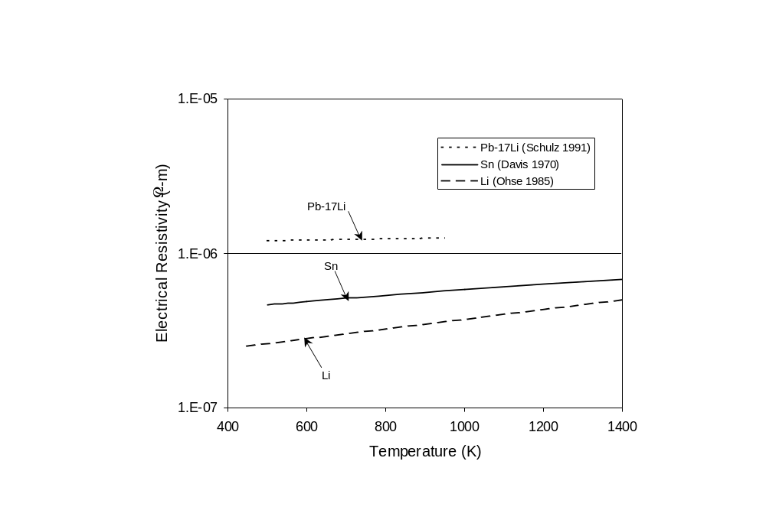
Figure 9: Electrical resistivity of liquid Sn, Pb-17Li, and Li.

References:
- B. Schulz, Fusion Eng. Design 14 (1991) 199.
- H. A. Davis, J. S. L. Leach, Phys. Chem. Liquids 2 (1970) 1/12, 5.
- R. W. Ohse (Ed.) Handbook of Thermodynamic and Transport Properties of Alkali metlas, Inter. Union of Pure and Applied Chemistry Chemical Data Series No. 30. Oxford: Blackwell Scientific Publ., 1985, pp. 987.

Surface Tension

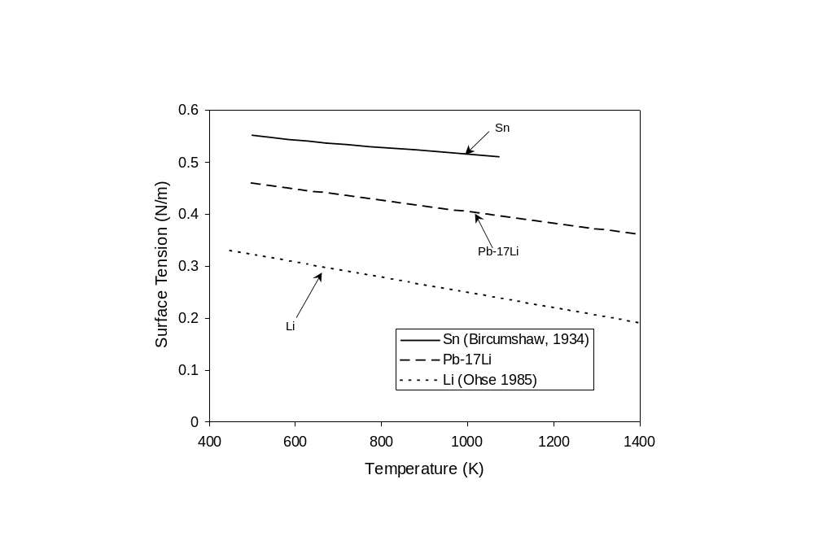
(Schulz, 1991)
Figure 10: Comparison of surface tension of liquid coolants

References:
- L.L. Bircumshaw, Phyl. Mag. 17 No. 7 (1934) 181/91, 186.
- B. Schulz, Fusion Eng. Design 14 (1991) 199.
- R. W. Ohse (Ed.) Handbook of Thermodynamic and Transport Properties of Alkali metlas, Inter. Union of Pure and Applied Chemistry Chemical Data Series No. 30. Oxford: Blackwell Scientific Publ., 1985, pp. 987.

Dynamic Viscosity
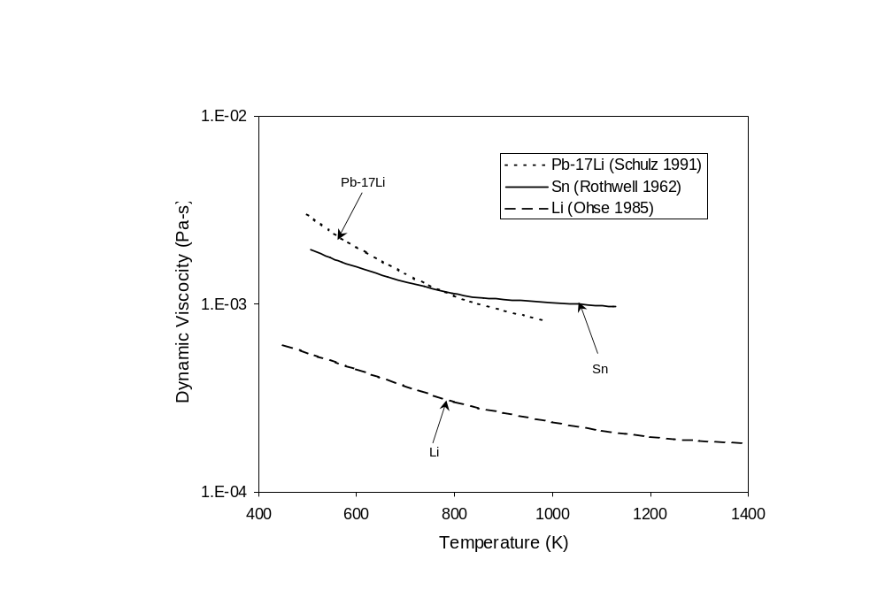
Figure 11: Comparison of the dynamic viscosity of liquid coolants.

References:
- B. Schulz, Fusion Eng. Design 14 (1991) 199.
- R. W. Ohse (Ed.) Handbook of Thermodynamic and Transport Properties of Alkali metlas, Inter. Union of Pure and Applied Chemistry Chemical Data Series No. 30. Oxford: Blackwell Scientific Publ., 1985, pp. 987.
- E. Rothwell, J. Inst. Metals 90 (1962) 38/94, 392.

Vapor Pressure
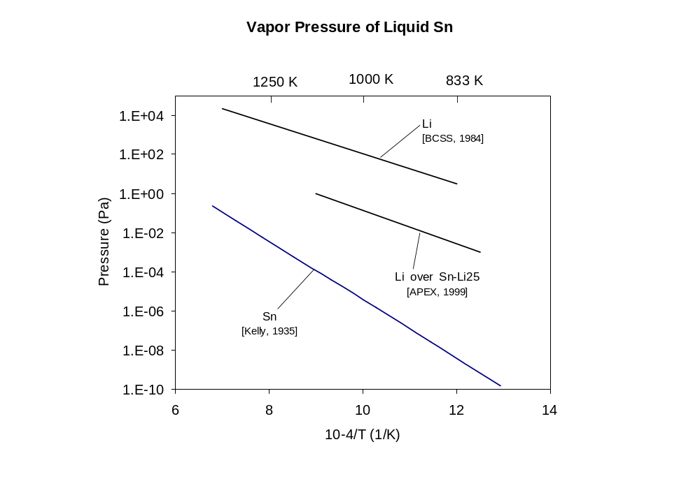
Figure 12: Comparison of the vapor pressure of liquid coolants.

References:
- K. K. Kelly, U.S. Bur. Mines Bull. Nr. 383 (1935) 1/132, 105.
- M. Abdou, et al., “On the Exploration of Innovative Concepts for Fusion Chamber Technology: APEX Interim Report,” University of California School of Engineering and Applied Science, UCLA-ENG-99-206, Nov. 1999.
- M. Abdou, et al., “ Blanket Comparison and Selection Study Final Report,” Argonne National Laboratory Report, ANL/FPP-84-1, Vol. 2.,1984

Density of Liquid Coolants
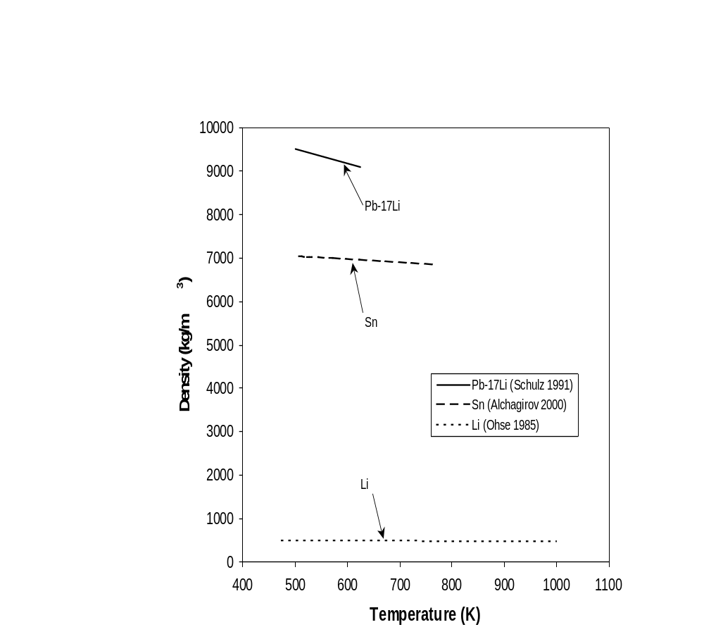
Figure 13: Comparison of the density of liquid coolants.

References:
- B. Schulz, Fusion Eng. Design 14 (1991) 199.
- R. W. Ohse (Ed.) Handbook of Thermodynamic and Transport Properties of Alkali metlas, Inter. Union of Pure and Applied Chemistry Chemical Data Series No. 30. Oxford: Blackwell Scientific Publ., 1985, pp. 987.
- B. B. Alchagirov, A. M. Chochaeva, “Temperature dependence of the density of liquid tin,” High Temperature 38: (1) 44-48, JAN-FEB 2000

Density of Liquid Sn-Li
The rule of mixtures is used to estimate the density of liquid Sn-Li compounds as a function of volume percent mixture at 500°C.
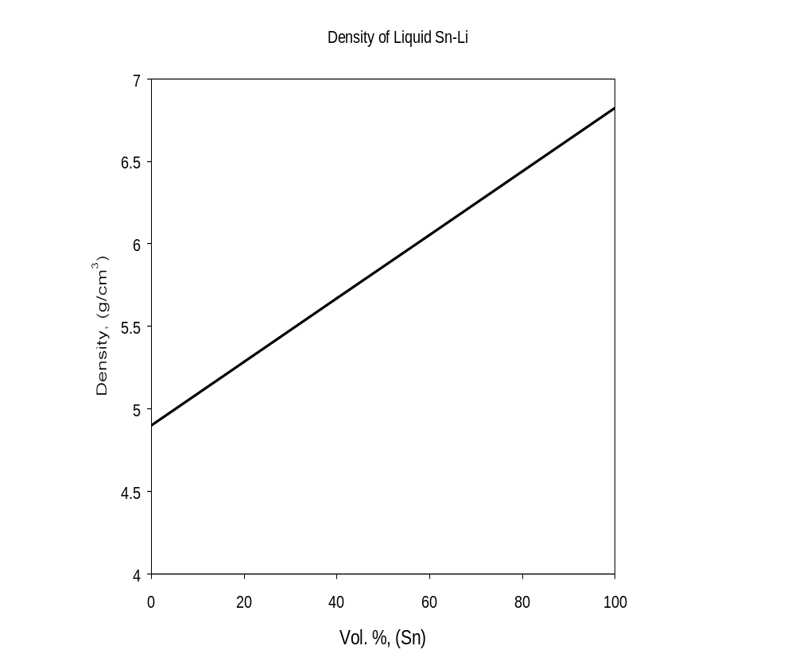
Figure 14: Estimated density of liquid Sn-Li at 500°C.

References:
- B. Schulz, Fusion Eng. Design 14 (1991) 199.
- R. W. Ohse (Ed.) Handbook of Thermodynamic and Transport Properties of Alkali metlas, Inter. Union of Pure and Applied Chemistry Chemical Data Series No. 30. Oxford: Blackwell Scientific Publ., 1985, pp. 987.
- B. B. Alchagirov, A. M. Chochaeva, “Temperature dependence of the density of liquid tin,” High Temperature 38: (1) 44-48, JAN-FEB 2000

Chemical Compatibility of Ceramic Materials with Sn-Li
We report here on our investigation of the stability of non-metallic coatings and alloying phases in liquid Sn-25Li. First, the activity-temperature-composition relationship of lithium in Sn-Li was estimated. Next, thermodynamic calculations of dissolved solutes (O, C, H, and N) were performed to determine their chemical activity as a function of temperature and composition in saturated liquid Sn-Li. Using the activity of the solutes and the Gibbs free energy of formation of corresponding lithium salts (Li₂O, LiH, Li₃N, and Li₂C₂) the stability region of these salts was mapped out as a function of temperature and composition. Finally, the stability of ceramic materials in Sn-25Li at 773°K was estimated using the Gibb’s free energy data of various oxide, nitride, and carbide ceramic materials.
The JANAF thermo-chemical tables were used for the formation Gibbs free energy data of lithium salts (Li₂O, LiH, Li₃N, Li₂C₂). It was found that the oxygen activity is low throughout the composition (20 to 80 at% Li) and the temperature range (500°C to 1500°C), therefore, Li₂O formation is favored. Thus, very low levels of dissolved oxygen can be expected in Sn-Li. Li₂C₂ was found to be stable at high temperatures above 900°C down to low Li-fractions (10%). Carbide coatings should therefore be resistant to dissolution in Sn-25Li. Lithium-nitride, Li₃N, formation is suppressed below 75% Li-fraction over the entire temperature range (500°C-1500°C), therefore, nitride coatings should also be resistant to dissolution. Lithium-hydride, LiH, activities are positive for almost all Li-fractions and the entire temperature range. Therefore, hydride salt formation is suppressed. This indicates, that tritium recovery from Sn-25Li should not pose a problem.
The nitrides are the most stable ceramics, followed by oxides, and then the carbides. However, among the oxides those of iron and nickel based alloys will probably not be stable. It can be assumed that iron and nickel based alloys will also not be preferred structural materials for Sn-Li. In summary, based on the solubility of O, N, H, and C in liquid lithium, the following stability results are found for nitride, oxides, and carbide-based coatings in Sn-25Li at 773°K (Fig. 18):

–Nitrides:
- At 500°C all of the considered nitrides are stable.
- ZrN is the most stable nitride.
–Oxides:
- The most stable oxides are: Sc₂O₃ and Y₂O₃
- Fe2O3, NiO, and Cr2O3 decompose.
- All other considered oxides were found to be stable.
- TiO2 SiO2 marginally stable.
- B2O3 is unstable at Li-fractions above 0.2.
–Carbides
- All carbides including SiC were found to be stable (note: β-SiC is unstable in pure Li).
- ZrC is the most stable carbide.

The most stable ceramics are nitrides, followed by oxides, and then by carbides.
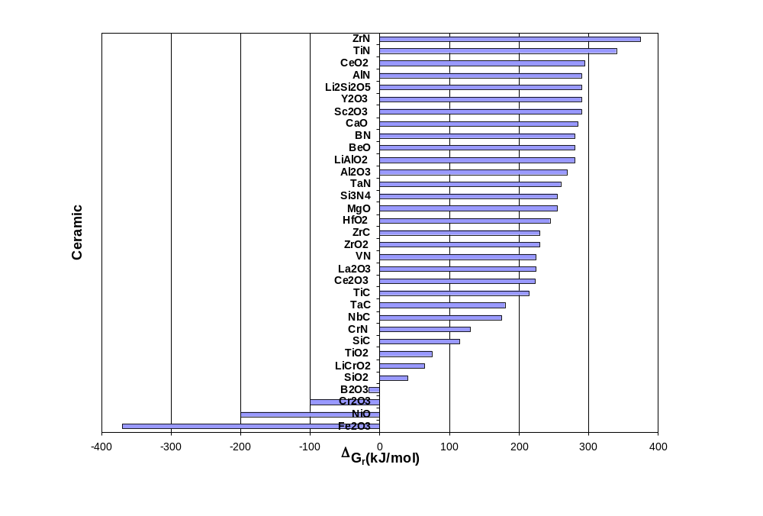
Stable
Unstable
Figure 15: Calculated stability of various nitrides, carbides and oxides in liquid Sn-25Li at 773°K.

Publications on Liquid Metal - Structural and Insulating Materials Interaction (1994 - 1999)

Publications Relating to Corrosion:
(Alphabetically ordered by author)

- Barbier, F., Alemany, A., “Magnetic field effect on the deposition of nickel in molten Pb-17Li.,” Journal of Nuclear Materials, J. Nucl. Mater. (Netherlands), vol.258-263, pt.A, (8th International Conference on Fusion Reactor Materials (CFRM-8), Sendai, Japan, 26-31 Oct. 1997.) Elsevier, Oct. 1998, p.508-12.
- Barbier, F., Alemany, A., Martemianov, S., “On the influence of a high magnetic field on the corrosion and deposition processes in the liquid Pb-17Li alloy,” Fusion Engineering and Design, Fusion Eng. Des. (Switzerland), vol.43, (no.2), Elsevier, Dec. 1998, p.199-208.
- Barbier, F., Blanc, J., “Corrosion of martensitic and austenitic steels in liquid gallium,” Journal of Materials Research, J. Mater. Res. (USA), vol.14, (no.3), Mater. Res. Soc, March 1999, p.737-44.
- Barker, M.G., Siddons, D.J., Barbier, F., “The removal of nickel dissolved in Pb-17Li by the formation of a less soluble nickel-manganese alloy.,” Journal of Nuclear Materials, J. Nucl. Mater. (Netherlands), vol.233-237B, (7th International Conference on Fusion Reactor Materials (ICFRM-7), Obninsk, Russia, 25-29 Sept. 1995.) Elsevier, 1 Oct. 1996, p.1436-40.
- Borgstedt, H.U., Glasbrenner, H., “Development of a direct insulation layer for a self-cooled liquid metal fusion reactor blanket.,” Fusion Engineering and Design, Fusion Eng. Des. (Netherlands), vol.27, (Third International Symposium on Fusion Nuclear Technology, Los Angeles, CA, USA, 26 June-1 July 1994.) 1995, p.659-62.
- Davis, G.D., Groff, G.B., Zatorski, R.A., “Plasma spray coatings as treatments for aluminum, titanium and steel adherends,” Surface and Interface Analysis, Surf. Interface Anal. (UK), vol.25, (no.5), Wiley, May 1997, p.366-73.
- Deb, D., Ramakrishna Iyer, S., Radhakrishnan, V.M., “Assessment of high temperature performance of a cast nickel base superalloy in corrosive environment.,” Scripta Materialia, Scr. Mater. (USA), vol.35, (no.8), Elsevier for Board of Directors of Acta Metall, 15 Oct. 1996, p.947-52.
- Dedyurin, A.I., Lyublinskii, I.E., Borovitskaya, I.V., “Corrosional stability of V-Ga alloys in lithium,” Metally, Metally (Russia) (no.3), Allerton Press, 1998, p.71-4. Translation:Russian Metallurgy, 1998 (no.3): 82-6.
- Donato, A., “Compatibility aspects of the Pb-17Li martensitic steel-H/sub 2/O system.,” Fusion Engineering and Design, Fusion Eng. Des. (Switzerland), vol.31, (no.2), Elsevier, June 1996, p.127-44.
- Dong-Sik Kim, Woo-Yang Chung, Byung-Ha Youn, “Influence of Ti in stainless steel melt on the corrosion of refractory materials.,” Journal of the Korean Institute of Metals and Materials, J. Korean Inst. Met. Mater. (South Korea), vol.33, (no.3), March 1995, p.340-9.
- Eberle, C.S., Raraz, A.G., Mishra, B., Olson, D.L., “Fused-salt-liquid-metal corrosion of refractory alloys in the presence of hot cell impurities.,” Transactions of the American Nuclear Society, Trans. Am. Nucl. Soc. (USA), vol.77, (1997 Winter Meeting. American Nuclear Society (papers in summary form only received), Albuquerque, NM, USA, 16-20 Nov. 1997.) ANS, 1997, p.166-7.
- Evtikhin, V.A., Lyublinski, I.E., Vertkov, A.V., “Compatibility of vanadium alloys and its weld joints in homogeneous and heterogeneous liquid lithium systems,” Journal of Nuclear Materials, J. Nucl. Mater. (Netherlands), vol.258-263, pt.B, (8th International Conference on Fusion Reactor Materials (CFRM-8), Sendai, Japan, 26-31 Oct. 1997.) Elsevier, Oct. 1998, p.1487-91.
- Evtikhin, V.A., Lyublinski, I.E., Vertkov, A.V., Korjavin, V.M., “Lithium-vanadium experimental facility for blanket problems Investigation,’’ Fusion Engineering and Design, Fusion Eng. Des. (Netherlands), vol.27, (Third International Symposium on Fusion Nuclear Technology, Los Angeles, CA, USA, 26 June-1 July 1994.) 1995, p.731-4.
- Feuerstein, H., Graebner, H., Oschinski, J., Horn, S., “Compatibility of refractory metals and beryllium with molten Pb-17Li.,” Journal of Nuclear Materials, J. Nucl. Mater. (Netherlands), vol.233-237B, (7th International Conference on Fusion Reactor Materials (ICFRM-7), Obninsk, Russia, 25-29 Sept. 1995.) Elsevier, 1 Oct. 1996, p.1383-6.
- Galvele, J.R., “Application of the surface-mobility stress corrosion cracking mechanism to nuclear materials.,” Journal of Nuclear Materials, J. Nucl. Mater. (Netherlands), vol.229, Elsevier, April 1996, p.139-48.
- Glasbrenner, H., Peric, Z., Borgstedt, H.U., “Alloying of aluminum and its influence on the properties of aluminide coatings: oxidation behavior and the chemical stability in Pb-17Li.,” Journal of Nuclear Materials, J. Nucl. Mater. (Netherlands), vol.233-237B, (7th International Conference on Fusion Reactor Materials (ICFRM-7), Obninsk, Russia, 25-29 Sept. 1995.) Elsevier, 1 Oct. 1996, p.1378-82.
- Hashimoto, K., Habazaki, H., Akiyama, E., Yoshioka, H., Kim, J.-M., Park, P.-Y., Kawashima, A., Asami, K., “Recent progress in corrosion-resistant new alloys prepared by sputter deposition.,” Science Reports of the Research Institutes, Tohoku University, Series A (Physics, Chemistry, and Metallurgy), Sci. Rep. Res. Inst. Tokohu Univ. A, Phys. Chem. Metall. (Japan), vol.42, (no.1), Tohoku Univ, March 1996, p.99-105.
- Hashimoto, K., Park, P.Y., Kim, J.H., Yoshioka, H., Mitsui, H., Akiyama, E., Habazaki, H., Kawashima, A., Asami, K., Grzesik, Z., Mrowec, S., “Recent progress in corrosion-resistant metastable alloys,” Materials Science & Engineering A (Structural Materials: Properties, Microstructure and Processing), Mater. Sci. Eng. A, Struct. Mater., Prop. Microstruct. Process. (Switzerland), vol.A198, (no.1-2), (3rd US-Japan Seminar on Development and Environmental Characteristics of New Materials, Mt. Hood, OR, USA, 7-9 June 1994.) 15 July 1995, p.1-10.
- Hayashi, Y., Masuda, M., Lee, J., Kojima, M., “Study on corrosion properties of sputter coating of oxides on stainless steels.,” Materials Science & Engineering A (Structural Materials: Properties, Microstructure and Processing), Mater. Sci. Eng. A, Struct. Mater., Prop. Microstruct. Process. (Switzerland), vol.A198, (no.1-2), (3rd US-Japan Seminar on Development and Environmental Characteristics of New Materials, Mt. Hood, OR, USA, 7-9 June 1994.) 15 July 1995, p.71-4.
- Heeg, B., Moros, T., Klenerman, D., “Persistency of corrosion inhibitor films on C-steel under multiphase flow conditions. I. The jet-cylinder arrangement,” Corrosion Science, Corros. Sci. (UK), vol.40, (no.8), Elsevier, Aug. 1998, p.1303-11.
- Hirai, S., Katayama, H.G., Sasaki, K., Kanisawa, H., “Formation of low aluminium Fe-Al layer on steel surface by hot dipping in molten Mg-Al bath.,” Journal of the Japan Institute of Metals, J. Jpn. Inst. Met. (Japan), vol.59, (no.3), March 1995, p.284-9.
- Hollenberg, G.W., Simonen, E.P., Kalinin, G., Terlain, A., “Tritium/hydrogen barrier development.,” Fusion Engineering and Design, Fusion Eng. Des. (Netherlands), vol.28, (Third International Symposium on Fusion Nuclear Technology, Los Angeles, CA, USA, 26 June-1 July 1994.) 1995, p.190-208.
- Hubberstey, P., “Pb-17Li and lithium: A thermodynamic rationalisation of their radically different chemistry,” Journal of Nuclear Materials, J. Nucl. Mater. (Netherlands), vol.247, (no.1-3), (9th International Symposium on Thermodynamics of Nuclear Materials, Osaka, Japan, 25-30 Aug. 1996.) Elsevier, Aug. 1997, p.208-14.
- Hubberstey, P., Sample, T., “Thermodynamics of the interactions between liquid breeders and ceramic coating materials,” Journal of Nuclear Materials, J. Nucl. Mater. (Netherlands), vol.248, (International Workshop on Interfacial Effects in Quantum Engineering Systems, Ibaraki, Japan, 21-23 Aug. 1996.) Elsevier, Sept. 1997, p.140-6.
- Indacochea, J.E., Smith, J.L., Litko, K.R., Karell, E.J., “Corrosion performance of ferrous and refractory metals in molten salts under reducing conditions,” Journal of Materials Research, J. Mater. Res. (USA), vol.14, (no.5), Mater. Res. Soc, May 1999, p.1990-5.
- Ishiwata, Y., Itoh, Y., Watanabe, R., “Corrosion behavior and its mechanism of Y/sub 2/O/sub 3/ dispersed W composite in molten metal.,” Journal of the Japan Institute of Metals, J. Jpn. Inst. Met. (Japan), vol.59, (no.7), July 1995, p.761-8.
- Ivanov, V.A., Afonina, Y.N., Soloviev, V.A., “Mass transfer in refractory alloy-stainless steel-liquid lithium heterogeneous system.,” Journal of Nuclear Materials, J. Nucl. Mater. (Netherlands), vol.233-237A, (7th International Conference on Fusion Reactor Materials (ICFRM-7), Obninsk, Russia, 25-29 Sept. 1995.) Elsevier, 1 Oct. 1996, p.581-5.
- Jian Ye, Sahai, Y., “Interaction and interfacial tension between aluminum alloys and molten salts.,” Materials Transactions, JIM, Mater. Trans. JIM (Japan), vol.37, (no.9), Japan Inst. Metals, Sept. 1996, p.1479-85.
- Korgul, P., Wilson, D.R., Lee, W.E., “Microstructural analysis of corroded alumina-spinel castable refractories,” Journal of the European Ceramic Society, J. Eur. Ceram. Soc. (UK), vol.17, (no.1), Elsevier, 1997, p.77-84.
- Kuo-Tong Ma, Yuh-Ming Ferng, Yin-Pang Ma, “Numerically investigating the influence of local flow behaviors on flow-accelerated corrosion using two-fluid equations,” Nuclear Technology, Nucl. Technol. (USA), vol.123, (no.1), American Nucl. Soc, July 1998, p.90-102.
- Lewis, M.B., Hunn, J.D., “Investigations of ion radiation effects at metal/liquid interfaces,” Journal of Nuclear Materials, J. Nucl. Mater. (Netherlands), vol.265, (no.3), Elsevier, March 1998, p.325-30.
- Liberski, P., Podolski, P., Gierek, A., Formanek, B., “Interaction of liquid zinc with non-metallic coatings on steel,” Materials Science Forum, Mater. Sci. Forum (Switzerland), vol.251-254, pt.2, (High Temperature Corrosion and Protection of Materials 4. 4th International Symposium, Les Embiez, France, 20-24 May 1996.) Trans Tech Publications, 1997, p.693-700.
- Lyublinski, I.E., Evtikhin, V.A., Ivanov, V.B., Kazakov, V.A., Korjavin, V.M., Markovchev, V.K., Melder, R.R., Revyakin, Y.L., Shpolyanskiy, V.N., “Vanadium-lithium in-pile loop for comprehensive tests of vanadium alloys and multipurpose coatings.,” Journal of Nuclear Materials, J. Nucl. Mater. (Netherlands), vol.233-237B, (7th International Conference on Fusion Reactor Materials (ICFRM-7), Obninsk, Russia, 25-29 Sept. 1995.) Elsevier, 1 Oct. 1996, p.1568-72.
- Mitsuyama, T., Terai, T., Yoneoka, T., Tanaka, S., “Compatibility of insulating ceramic materials with liquid breeders,” Fusion Engineering and Design, Fusion Eng. Des. (Switzerland), vol.39-40, (4th International Symposium on Fusion Nuclear Technology, Tokyo, Japan, 6-11 April 1997.) Elsevier, Sept. 1998, p.811-17.
- Mitsuyama, T., Yoneoka, T., Terai, T., Tanaka, S., “Compatibility of ceramic coating materials with liquid tritium breeder for fusion blankets,” Annual Report of Engineering Research Institute, School of Engineering, University of Tokyo, Annu. Rep. Eng. Res. Inst. Sch. Eng. Univ. Tokyo (Japan), vol.56, Univ. Tokyo, Sept. 1997, p.157-62.
- Nakamichi, M., Kawamura, H., Terai, T., Tanaka, S., “Characterization of Y/sub 2/O/sub 3/ coating for liquid blanket,” Journal of Nuclear Materials, J. Nucl. Mater. (Netherlands), vol.248, (International Workshop on Interfacial Effects in Quantum Engineering Systems, Ibaraki, Japan, 21-23 Aug. 1996.) Elsevier, Sept. 1997, p.165-9.
- Narh, K.A., Dwivedi, V.P., Grow, J.M., Stana, A., Shih, W.-Y., “The effect of liquid gallium on the strengths of stainless steel and thermoplastics,” Journal of Materials Science, J. Mater. Sci. (UK), vol.33, (no.2), Chapman & Hall, 15 Jan. 1998, p.329-37.
- Natesan, K., “Fabrication and performance of AlN insulator coatings for application in fusion reactor blankets.,” Journal of Nuclear Materials, J. Nucl. Mater. (Netherlands), vol.233-237B, (7th International Conference on Fusion Reactor Materials (ICFRM-7), Obninsk, Russia, 25-29 Sept. 1995.) Elsevier, 1 Oct. 1996, p.1403-10.
- Natesan, K., Reed, C.B., Mattas, R.F., “Assessment of alkali metal coolants for the ITER blanket.,” Fusion Engineering and Design, Fusion Eng. Des. (Netherlands), vol.27, (Third International Symposium on Fusion Nuclear Technology, Los Angeles, CA, USA, 26 June-1 July 1994.) 1995, p.457-66.
- Natesan, K., Reed, C.B., Rink, D.L., Haglund, R.C., “Development and performance of aluminum nitride insulating coatings for application in a lithium environment.,“ Journal of Nuclear Materials, J. Nucl. Mater. (Netherlands), vol.258-263, pt.A, (8th International Conference on Fusion Reactor Materials (CFRM-8), Sendai, Japan, 26-31 Oct. 1997.) Elsevier, Oct. 1998, p.488-94.
- Ota, K., Motohira, N., Kobayasi, M., Baek-Un Kim, Kamiya, N., Yokokawa, H., “High temperature corrosion of Cr with the presence of molten carbonate [fuel cells].,” Denki Kagaku, Denki Kagaku (Japan), vol.64, (no.6), Electrochem. Soc. Japan, June 1996, p.464-70.
- Pan Qingchun, Shan Bingquan, Tian Yun, Liu Guangzu, “Corrosion behavior of oxide dispersion strengthened ferritic alloys in liquid sodium,” Journal of Iron and Steel Research International, J. Iron Steel Res. Int. (China), vol.5, (no.1), Editorial Board J. Iron & Steel Res. Int, April 1998, p.46-50.
- Park, J.-H. Edited by: Dahotre, N.B., Hampikian, J.M., Stiglich, J.J., “Intermetallic and electrical insulator coatings on high-temperature alloys in liquid-lithium environments.,” (Elevated Temperature Coatings: Science and Technology I. Proceedings of a Symposium: High Temperature Coatings - I, Proceedings of Elevated Temperature Coatings: Science and Technology I, Rosemont, IL, USA, 3-6 Oct. 1994.) Warrendale, PA, USA: TMS, 1995, p.227-40. x+425 pp.
- Park, J.H., Cho, W.D., “Intermetallic and electrical insulator coatings on high temperature alloys, properties in liquid-lithium environments,’’ Materials and Manufacturing Processes, Mater. Manuf. Process. (USA), vol.10, (no.5), 1995, p.971-86.
- Park, J.-H., Domenico, T., Dragel, G., Clark, R., “Development of electrical insulator coatings for fusion power applications.,” Fusion Engineering and Design, Fusion Eng. Des. (Netherlands), vol.27, (Third International Symposium on Fusion Nuclear Technology, Los Angeles, CA, USA, 26 June-1 July 1994.) 1995, p.682-95.
- Park, J.-H., Kassner, T.F., “CaO insulator coatings and self-healing of defects on V-Cr-Ti alloys in liquid lithium system.,” Journal of Nuclear Materials, J. Nucl. Mater. (Netherlands), vol.233-237A, (7th International Conference on Fusion Reactor Materials (ICFRM-7), Obninsk, Russia, 25-29 Sept. 1995.) Elsevier, 1 Oct. 1996, p.476-81.
- Park, J.J., Buksa, J.J., “Selection of flowing liquid lead target structural materials for accelerator driven transmutation applications.,” AIP Conference Proceedings, AIP Conf. Proc. (USA) (no.346), (International Conference on Accelerator-Driven Transmutation Technologies and Applications, Las Vegas, NV, USA, July 1994.) AIP, 1995, p.512-18.
- Rizk, T.Y., Thompson, G.E., Dawson, J.L., “Mass transfer enhancement associated with sudden flow expansion.,” Corrosion Science, Corros. Sci. (UK), vol.38, (no.10), Elsevier, Oct. 1996, p.1801-14.
- Sagara, A., Motojima, O., Mitarai, O., Imagawa, S., Watanabe, K., Yamanishi, H., Chikaraishi, H., Kohyama, A., Matsui, H., Muroga, T., Noda, N., Noda, T., Ohyabu, N., Satow, T., Shishkin, A.A., Tanaka, S., Terai, T., Yamazaki, K., Yamamoto, J., “Blanket design using FLiBe in helical-type fusion reactor FFHR,” Journal of Nuclear Materials, J. Nucl. Mater. (Netherlands), vol.248, (International Workshop on Interfacial Effects in Quantum Engineering Systems, Ibaraki, Japan, 21-23 Aug. 1996.) Elsevier, Sept. 1997, p.147-52.
- Santos, J., Perdigao, J., “Corrosion detection and classification by spectral analysis.,” Insight-Non-Destructive Testing and Condition Monitoring, Insight, Non-Destr. Test. Cond. Monit. (UK), vol.38, (no.3), British Inst. Non-Destructive Testing, March 1996, p.202-6.
- Simon, N., Terlain, A., Flament, T., “The compatibility of martensitic steels with liquid Pb-17Li,” Journal of Nuclear Materials, J. Nucl. Mater. (Netherlands), vol.254, (no.2-3), Elsevier, 17 April 1998, p.185-90.
- Smith, D.L., Chung, H.M., Loomis, B.A., Matsui, H., Votinov, S., Van Witzenburg, W., “Development of vanadium-base alloys for fusion first-wall-blanket applications.,” Fusion Engineering and Design, Fusion Eng. Des. (Netherlands), vol.29, (Third International Symposium on Fusion Nuclear Technology, Los Angeles, CA, USA, 26 June-1 July 1994.) 1995, p.399-410.
- Stack, M.M., Chacon-Nava, J., Stott, F.H., “Relationship between the effects of velocity and alloy corrosion resistance in erosion-corrosion environments at elevated temperatures.,” Wear, Wear (Switzerland), vol.180, (no.1-2), Jan. 1995, p.91-9.
- Terai, T., “Research and development on ceramic coatings for fusion reactor liquid blankets,” Journal of Nuclear Materials, J. Nucl. Mater. (Netherlands), vol.248, (International Workshop on Interfacial Effects in Quantum Engineering Systems, Ibaraki, Japan, 21-23 Aug. 1996.) Elsevier, Sept. 1997, p.153-8.
- Terai, T., Mitsuyama, T., Yoneoka, T., Tanaka, S., “Compatibility of insulating ceramic with liquid breeders,” Journal of Nuclear Materials, J. Nucl. Mater. (Netherlands), vol.253, (5th International Symposium on Fabrication and Properties of Ceramics for Fusion Energy and Other High Radiation Environments at the 99th Annual Meeting of the American Ceramics Society, Cincinnati, OH, USA, 5-7 May 1997.) Elsevier, March 1998, p.219-26.
- Terai, T., Yoneoka, T., Tanaka, H., Suzuki, A., Tanaka, S., Nakamichi, M., Kawamura, H., Miyajima, K., Harada, Y., “Compatibility of yttria (Y/sub 2/O/sub 3/) with liquid lithium.,” Journal of Nuclear Materials, J. Nucl. Mater. (Netherlands), vol.233-237B, (7th International Conference on Fusion Reactor Materials (ICFRM-7), Obninsk, Russia, 25-29 Sept. 1995.) Elsevier, 1 Oct. 1996, p.1421-6.
- Tostmann, H., Nattland, D., Freyland, W. Edited by: Andricacos, P.C., Corcoran, S.G., Delplancke, J.-L., Moffat, T.P., Searson, P.S., “In-situ characterization of oxide films on liquid alkali metals using second harmonic generation (SHG).,” (Electrochemical Synthesis and Modification of Materials. Symposium, Electrochemical Synthesis and Modification of Materials. Symposium, Boston, MA, USA, 2-5 Dec. 1996.) Pittsburgh, PA, USA: Mater. Res. Soc, 1997, p.579-84. xiii+592 pp.
- Tsirlin, M., Eidelmann, A., Lesin, S., Branover, H., “The specific mode of corrosion damage of copper in liquid lead turbulent flow.,” Journal of Materials Science Letters, J. Mater. Sci. Lett. (UK), vol.15, (no.6), Chapman & Hall, 15 March 1996, p.508-10.
- Tsirlin, M., Lesin, S., Branover, H., “The selective corrosion of type 316 stainless steel in molten lead.,” Journal of Materials Science Letters, J. Mater. Sci. Lett. (UK), vol.14, (no.20), 15 Oct. 1995, p.1476-8.
- Turnbull, A., Griffiths, A.J., “Implications of hydrogen uptake and transport for environment assisted cracking testing and interpretation of results.,” British Corrosion Journal, Br. Corros. J. (UK), vol.31, (no.1), Inst. Mater, 1996, p.39-43.
- Vertkov, A.V., Evtikhin, V.A., Lyublinski, I.E., “The vanadium alloys technological and corrosion studies in construction and operation of liquid metal facilities for fusion reactor.,” Journal of Nuclear Materials, J. Nucl. Mater. (Netherlands), vol.233-237A, (7th International Conference on Fusion Reactor Materials (ICFRM-7), Obninsk, Russia, 25-29 Sept. 1995.) Elsevier, 1 Oct. 1996, p.452-5.
- Virieux, X.Y., Desmaison, J., Labbe, J.C., Gabriel, A., “Interaction between two Ni-base alloys and oxide ceramics: SiO/sub 2/, ZrO/sub 2/, HfO/sub 2/, Al/sub 2/O/sub 3/,” Materials Science Forum, Mater. Sci. Forum (Switzerland), vol.251-254, pt.2, (High Temperature Corrosion and Protection of Materials 4. 4th International Symposium, Les Embiez, France, 20-24 May 1996.) Trans Tech Publications, 1997, p.925-32.
- Yashiro, H., Pound, B., Kumagai, N., Tanno, K., “The effect of permeated hydrogen on the pitting of type 304 stainless steel,” Corrosion Science, Corros. Sci. (UK), vol.40, (no.4-5), Elsevier, April-May 1998, p.781-91.
- Yoneoka, T., Mituyama, T., Terai, T., Tanaka, S. Edited by: Varandas, C., Serra, F., “Compatibility of insulating ceramic materials with molten lithium metal.,” (vol.2), (Fusion Technology 1996. Proceedings of the 19th Symposium on Fusion Technology, Fusion Technology 1996. Proceedings of the 19th Symposium on Fusion Technology, Lisbon, Portugal, 16-20 Sept. 1996.) Amsterdam, Netherlands: Elsevier, 1997, p.1535-8 vol.2. 2 vol. (xlii+xxxviii+1874) pp.
- Yoneoka, T., Terai, T., Takahashi, Y., “High temperature liquid metal corrosion and high temperature electrical conductivity of Y/sub 2/O/sub 3/,” Journal of Nuclear Materials, J. Nucl. Mater. (Netherlands), vol.248, (International Workshop on Interfacial Effects in Quantum Engineering Systems, Ibaraki, Japan, 21-23 Aug. 1996.) Elsevier, Sept. 1997, p.343-7.

Publications Relating to Erosion:
(Alphabetically ordered by author)

- Aliev, I.N., Temlyantsev, V.Yu., “Parametric instability of the surface of a conductive liquid in a uniform field in the presence of a plane screen parallel to the surface.,” Magnitnaya Gidrodinamika, Magn. Gidrodin. (Latvia), vol.33, (no.1), Plenum, Jan.-March 1997, p.118-19 . Translation:Magnetohydrodynamics, Jan.-March 1997, vol.33, (no.1): 97-8.
- Batrakov, A.V., Popov, C.A., Proskurovsky, D.I., “Investigation into the erosion of explosive-emission liquid-metal cathodes.,” (vol.2), (Proceedings ISDEIV. 17th International Symposium on Discharges and Electrical Insulation in Vacuum (Cat. No.96CH35839), Proceedings of 17th International Symposium on Discharges and Electrical Insulation in Vacuum, Berkeley, CA, USA, 21-26 July 1996.) New York, NY, USA: IEEE, 1996, p.752-6 vol.2.
- Batrakov, A.V., Popov, S.A., Proskurovsky, D.I., “Investigation into the erosion of explosive-emission liquid-metal cathodes.,” IEEE Transactions on Plasma Science, IEEE Trans. Plasma Sci. (USA), vol.25, (no.4), (17th International Symposium on Discharges and Electrical Insulation in Vacuum (ISDEIV), Berkeley, CA, USA, 21-26 July 1996.) IEEE, Aug. 1997, p.538-42 .
- Brooks, J.N. Edited by: Miley, G.H., Elliot, C., “Divertor erosion study for TPX and implications for steady-state fusion reactors.,” (vol.2), (16th IEEE/NPSS Symposium Fusion Engineering, SOFE '95. Seeking a New Energy Era (Cat. No.95CH35852), Proceedings of 16th International Symposium on Fusion Engineering, Champaign, IL, USA, 30 Sept.-5 Oct. 1995.) New York, NY, USA: IEEE, 1995, p.1279-82 vol.2.
- Chatillon, C., Coudurier, L., Eustathopoulos, N., “Stability of oxide films on liquid metals under vacuum: influence on wetting of metals on ceramic surfaces.,” Materials Science Forum, Mater. Sci. Forum (Switzerland), vol.251-254, pt.2, (High Temperature Corrosion and Protection of Materials 4. 4th International Symposium, Les Embiez, France, 20-24 May 1996.) Trans Tech Publications, 1997, p.701-8 .
- Heeg, B., Moros, T., Klenerman, D., “Persistency of corrosion inhibitor films on C-steel under multiphase flow conditions. I. The jet-cylinder arrangement.,” Corrosion Science, Corros. Sci. (UK), vol.40, (no.8), Elsevier, Aug. 1998, p.1303-11 .
- Neville, A., Hodgkiess, T., “Study of effect of liquid corrosivity in liquid-solid impingement on cast iron and austenitic stainless steel.,” British Corrosion Journal, Br. Corros. J. (UK), vol.32, (no.3), Inst. Mater, 1997, p.197-205 .
- Popov, S.A., Proskurovsky, D.I., Batrakov, A.V., “Investigation of the erosion drop fraction for liquid-metal explosive-emission cathodes.,” IEEE Transactions on Plasma Science, IEEE Trans. Plasma Sci. (USA), vol.27, (no.4), (Proceedings of 18th International Symposium on Discharges and Electrical Insulation in Vacuum, Eindhoven, Netherlands, 17-21 Aug. 1998.) IEEE, Aug. 1999, p.851-7 .
- Stack, M.M., Chacon-Nava, J., Stott, F.H., “Relationship between the effects of velocity and alloy corrosion resistance in erosion-corrosion environments at elevated temperatures.,” Wear, Wear (Switzerland), vol.180, (no.1-2), Jan. 1995, p.91-9 .

Selected Titles on Corrosion and Erosion:
- International Conference on Liquid Metal Technology in Energy Production (2nd : 1980 : Richland, Wash.), “Second International Conference on Liquid Metal Technology in Energy Production, “ Proceedings / editor, J.M. Dahlke ; sponsored by the American Nuclear Society, Materials, Science and Technology Division and the Richland Washington Section, April 20-24, 1980, Richland, Washington., [Washington] : U.S. Dept. of Energy ; Springfield, Va. : available from National Technical Information Service, U.S. Dept. of Commerce, 1980.
- “Application of 2 1/4 Cr-1 Mo as a structural material in saturated steam cycle LMFBR systems,” prepared by General Electric Company, Advanced Reactor Systems Department; contributors, G.J. Licina [et al.], Palo Alto, Calif. : Electric Power Research Institute, c 1982.
- Girard, J. E., “Trace metal analysis by high-performance liquid chromatography interfaced to an electrochemical detector, “ prepared by The American University, Department of Chemistry; principal investigator, J. E. Girard., Palo Alto, Calif. : Electric Power Research Institute, c1984.
- Petroski, H. J., “Plane-strain stress intensity factors for cracked hexagonal subassembly ducts, “ by H. J. Petroski, J. L. Glazik, Reactor Analysis and Safety Division, and J. D. Achenbach, Department of Civil Engineering, Northwestern University., Argonne, Ill. : Argonne National Laboratory ; [Springfield, Va. : for sale by the National Technical Information Service], 1977.
- Zima, G. E., “On the corrosion adequacy of the 2 1/4 Cr-1Mo steel for LMFBR steam generation system service,” prepared by the G.E. Zima ; prepared for Division of Systems Safety, Office of Nuclear Reactor Regulation, U.S. Nuclear Regulation, U.S. Nuclear Regulatory Commission., Washington, D.C. : The Commission : Available from GPO Sales Program, Division of Technical Information and Document Control, U.S. Nuclear Regulatory Commission ; Springfield, Va. : National Technical Information Service, 1980.
- Petroski, H. J., “Plane-strain stress intensity factors for cracked hexagonal subassembly ducts, “by H. J. Petroski, J. L. Glazik, Reactor Analysis and Safety Division, and J. D. Achenbach, Department of Civil Engineering, Northwestern University., Argonne, Ill. : Dept. of Energy, Argonne National Laboratory ; [Springfield, Va. : for sale by the National Technical Information Service], 1977.
- Zima, G. E., “A corrosion critique of the 2 1/4 Cr-1 Mo steel for LMFBR steam generation system applications, “ G. E. Zima., Washington : Nuclear Regulatory Commission, Office of Nuclear Reactor Regulation, Division of Systems Safety ; Springfield, Va. : for sale by the National Technical Information Service, 1977.

The list is by no means to be considered complete.

